
2025C
Project 1

Caring System (Nanny)

Eric Yeong Hong Wei (D240288C)
Louis Tey Chi Feng (D240168C)
Lee Kai Siang (D240300C)

Supervisor: Ms Shaffika Bte Mohd Suhaimi

Submission Date: 2025

Department of Information Technology



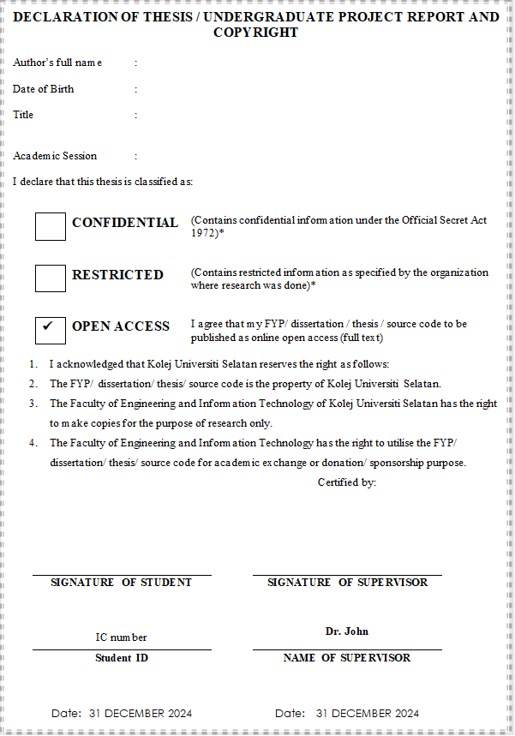
Notes: If the FYP/ dissertation / thesis / source code is CONFIDENTIAL or RESTRICTED, please attach with the Non-Disclosure Agreement (NDA) or letter from the organisation / department with period and reasons for confidentiality or restriction as appendices.
DECLARATION OF COPYRIGHT

I hereby declare that this FYP/dissertation/thesis entitled “AI-POWERED PERSONALIZED DINING ASSISTANT” to be kept by Southern University College subject to the regulations as follows:
1. This FYP/dissertation/thesis is a property of Southern University College.
2. Southern University College or its library has the right to make and transmit copies (print or electronic) of this FYP/dissertation/thesis for academic purposes.
3. Southern University College or its library has the right to store this FYP/dissertation/thesis in a retrieval system and supply copies of this FYP/dissertation/thesis if requested by other universities and research libraries.

Signature : _________________________

Name : _________________________

ID No. : _________________________

Date : _________________________

DECLARATION OF RESPONSIBLE ARTIFICIAL INTELLIGENCE

I, the undersigned hereby declare that this FYP/dissertation/thesis entitled “AI-POWERED PERSONALIZED DINING ASSISTANT” involving artificial intelligence (AI).
Tick if use | Level | Level of AI Use | Description | Disclosure Requirements
√ | 0 | NO AI Use | This final year project is completed without AI assistance.
√ | 1 | AI-assisted Idea Generation and Structuring | AI is used for brainstorming. | Appendix C: AI Chat / Prompt History
√ | 2 | AI- Assisted Editing | AI is used to make improvements to the clarity or quality of student created work to improve the final output. | Appendix D: Paraphrasing tools
√ | 3 | AI for Specified Completion | AI is used to complete certain tasks listed in this final year project. | Appendix E: AI tools
 | 4 | Full AI Use with Human Oversight | AI is used as ‘co-pilot’ to enhance human creativity. Student is responsible for providing human oversight and evaluation of all AI generated content. | Appendix E: AI tools

By signing this declaration, I am responsible in my use of AI technologies throughout this FYP/ dissertation/ thesis.

Signature : _________________________

Name : _________________________

ID No. : _________________________

Date : _________________________

Abstract
This report presents the design and development of an AI-powered personalized dining assistant app, which aims to revolutionize the dining experience by offering tailored restaurant and recipe recommendations. The app focuses on enhancing user satisfaction by utilizing AI machine learning to analyze user preferences, dietary restrictions, and real-time factors such as location and weather. The system supports three user roles: customer, restaurant owner, and admin, each with specific functionalities to ensure seamless interaction and management.

The project was developed using the Agile methodology, which allowed for iterative development and continuous feedback from stakeholders. This approach facilitated the refinement of key features, including the recommendation engine, restaurant registration and verification process, and user account management. Regular sprints and user feedback sessions ensured that the app evolved to meet user needs effectively.

The main findings of the report highlight the importance of accurate data collection and AI integration in delivering relevant recommendations. The system’s ability to adapt to changing user preferences and external conditions is critical for maintaining user engagement and satisfaction. Additionally, the report emphasizes the need for robust security measures, especially in handling sensitive user data and preventing fake restaurant registrations.

The conclusion of this project is that the app successfully meets its goals of providing personalized dining experiences, as evidenced by positive feedback from test users. However, further improvements can be made in areas such as scalability and user onboarding. Key recommendations include enhancing the app's scalability through cloud infrastructure, refining the AI algorithms for more precise recommendations, and expanding the recipe database to include a wider variety of user-submitted content.

Overall, this project demonstrates the potential of AI-powered personalized assistant in the dining industry, offering significant value to both customers and restaurant owners. The application’s user-friendly interface, combined with intelligent recommendations, positions it as a unique solution in the competitive food tech market.

Acknowledgements
We would like to express our deepest gratitude to everyone who supported and contributed to the successful completion of this project.

First, we would like to thank Ms Shaffika, my project supervisor, for her invaluable guidance, insights, and encouragement throughout the development process. Her expertise and feedback were crucial in shaping the direction of this project.

We would also like to extend my sincere appreciation to the other lecturer at Southern University College for providing the necessary resources and support, including access to development tools, testing environments, and technical assistance.

Finally, we would like to thank each other teammates, friends and family for their continuous encouragement and support, which has been a source of motivation throughout this journey. All contributions have been invaluable to the successful realization of this project.

Table of contents
Chapter 1： Introduction 8
1.1 Background Research 8
1.2 Issue 8
1.3 Research Objectives 9
1.4 Project Scope 10
1.5 Significance of the Study 11
1.6 Summary 11
Chapter 2 11
2.1 Introduction 12
2.1.1 Interview Methodology 12
2.1.2 Key Findings from Interviews 14
2.2 Current system 14
2.2.1Kiddocare 15
2.2.2 Sitty 15
2.2.3Homage 16
2.3 Compare Between 3 Existing Systems 16
2.3.1 Comparison Table 17
2.4 Current Technology Used 18
2.5 Summary 19
Chapter 3: Methodology 20
3.1 Introduction 21
3.2 Methodology Choice and Justification 21
3.3 Phases Within the Chosen Methodology/ Planning 22
3.4 Technology / Tools Used 24
3.5 System Requirements Analysis 26
3.5.1 Hardware 26
3.5.2 Software 26
3.6 Gantt Chart 27
3.7 Financial Justification 27
3.8 Summary 28
Chapter 4: Design 28
4.1 Introduction 29
4.2 Use case diagram 29
4.2.1 Overall Nanny System 30
4.2.2 User Account Management 31
4.2.3 Review and Rating Management 34
4.2.4 Chat System Management 36
4.2.5 AI Recommendation 38
4.3 Class Diagram 41
4.4 Entity Relationship Diagram （ERD） 41
4.5 Data Flow Diagram (DFD) 42
4.5.1 Context Level 43
4.5.2 DFD Level 0 43
4.5.3 Level 1 44
4.6 Activity Diagram 49
4.7 System Architecture (Prototype) 52
4.7.1 Parent 53
4.7.2 Nanny 62
4.8 Summary 65
Chapter 5: Implementation, Testing , Analysis or Evaluation 66
5.1 Introduction 67
5.2 Implementation 67
5.2.1 Ai Match Engine 67
5.2.2 Smart Booking Engine 68
5.2.3 Rating System with Image Upload 68
5.3 Testing 69
5.3.1 Sample Population and Participant Selection 69
5.3.2 Automation and Performance Testing Strategies 69
5.3.3 Testing Methodology & Participant Selection 70
5.3.4 Test levels & Implementation 70
5.5 Analysis or Evaluation 73
5.6 Summary 75
Chapter 6: Conclusion 75
6.1 Introduction 76
6.2 Achievements 76
6.3 Limitation 76
6.4 Future work / Recommendation 77
6.5 Summary 77
References 78
Appendix B: Similarity Report 81
Appendix C: AI Chat/ Prompt History 82
Appendix D: Paraphrasing Tools 83
Appendix E: AI tools 84
Appendix F: Video Presentation 85

Topic: Caring (Nanny system)

Chapter 1： Introduction

1.1 Background Research
Nowadays, parents are doing more than just working, they're engaged in a constant, exhausting balancing act. It's very hard to find enough quality time to take care well for their children or elderly since they have busy jobs and a lot going on in their daily lives. This isn't just busyness. It's a profound strain on the modern family. What families desperately need is one thing: dependable, trustworthy support they can absolutely count on.

Historically, finding that support meant exhausting yourself with asking around or navigating complex local agencies. But these methods are painfully slow and frustrating. You might get a name from a friend, but that referral comes with zero transparency which are you don't know their verified experience, their true reliability, or even if they're available when you need them most. Trusting someone new with your family is a huge decision and having to do it without clear information is a stressful, emotional, and draining ordeal.

We use technology for literally everything else ordering dinner, booking flights, managing our finances. So why hasn't that same convenience and security reached caregiving? Most current online platforms simply aren't built for real family needs. Some are too generic, missing the specific, unique requirements of either childcare or elder support. Critically, others lack the basic safety features we deserve which is mandatory background checks, verified profiles, or honest, transparent reviews. This leaves good families feeling stuck and alone, forced to choose between a risky, unverified option or staying overwhelmed.

That's the precise, critical reason we're building the Nanny System. This is a platform created for real families, designed to be simple, secure, and genuinely helpful. Parents will easily find experienced, thoroughly verified caregivers and see honest feedback from other families. We provide a robust login system, mandatory checks, and simple tools to book appointments and manage schedules. For caregivers, it’s a streamlined chance to grow their careers and connect with the families who truly need them. Our simple, driving goal is to make the foundational act of finding care easier, safer, and completely transparent for everyone involved.

1.2 Issue
Nowadays, many people need to work in other cities or are away from home for extended periods, making it difficult to properly care for their children or elderly family members. As a result, they need to hire nannies to help address this issue. However, as we know, the nanny systems often have numerous safety concerns, such as instances of violence or theft, which cause many families to worry that nannies may not be able to adequately take care of their elderly relatives or children. Current practice, they keep sending their kids to the mother who is now already old and weak to care the kids. In addition, they also pay Taska, playschool to look after the kids. However this services will not available on weekends or after working hour.
1.Challenges of Modern Lifestyles: In today's fast-paced Malaysian society, many individuals are compelled to relocate to other cities or work long hours in order to maintain their careers and economic stability. This lifestyle makes it increasingly difficult for them to find time to spend with their children or elderly family members. Since both parents typically need to work full-time, families find it challenging to balance work responsibilities with caregiving duties. This situation has led to a growing demand for reliable and flexible household and caregiving support.
2. Known nannies on the market are unreliable: To cope with these challenges, many families choose to hire nannies or domestic helpers to care for children or elderly relatives. When parents or guardians are not present, nannies play a crucial role in ensuring daily needs are met, such as feeding, supervision, and emotional support. However, finding a trustworthy and skilled nanny is not easy. Most families rely on personal recommendations or informal networks, which may not sufficiently guarantee the nanny's background or experience.
3. Safety and Trust Issues: A major problem with the current nanny system is the lack of effective verification and supervision. There have been cases where some nannies were reported for theft, negligence, or even child abuse, which deeply concerns parents. Many families worry that the nannies they hire may lack the necessary training, experience, or sense of moral responsibility to provide safe and high-quality care. This lack of transparency and accountability hinders families who need assistance but are concerned about potential risks from seeking help.

4. The Burden on Elderly Caregivers: In many cases, parents who cannot find suitable childcare often rely on grandparents to look after their children. However, in the long term, this solution is not ideal. Elderly caregivers may already face health issues, fatigue, and mobility limitations. Caring for young children is a significant physical and mental burden, which can affect not only the health of the elderly but also the quality of care they can provide to the children. Therefore, it is important to have a sustainable and well-supported care plan.

5. Limitations of Daycare and Play Schools (Taska): Daycare centers, kindergartens, or play schools are another common childcare option for working parents. While they provide a structured and safe environment during working hours, their operating hours are usually limited to weekdays during the day. Parents who work shifts, weekends, or night shifts may find it difficult to arrange childcare outside of these hours. Moreover, for parents who need to travel further for work, these options become even less suitable, and these limitations have caused many challenges.

1.3 Research Objectives
1)To design a user-friendly system that having the AI recommendation system to allows parents to search for and hire nannies based on their needs, location, and availability.
2) Implement a nanny verification and rating system to ensure trust and safety. To achieve this, we have required nannies to provide profiles for parents to view. At the same time to protect nanny safety, that nanny also can know the customer information as well.
3) Provide scheduling, communication chat, and payment features to improve convenience for both parties. To ensure data privacy and transaction security within the system.

1.4 Project Scope
The scope of this project includes the development of a nanny management system targeted at parents and childcare providers. Reassure parents about any safety concerns, quickly obtain information and reviews about nannies, and book a nanny at a reasonable price.
- Target Audience:
- Provide parents with a better and more convenient nanny system to select a satisfactory caregiver without any safety hazards.
- Provide nanny employment opportunities.
- Deliverables:
- A fully featured application that includes AI, capable of recommending suitable nannies based on user needs, as well as enhancing security and user experience.
- User roles
- Functions for parents:
Create an accounts or log in their accounts, search nannies by the AI recommendation system by location or skills, view nannie’s profiles and reviews, make booking, and process payments. After booking and nannies start working, parents are able to look their location and nanny’s perspective through the live location from the system
- Function for nannies:
Register profiles, upload credentials, set availability, manage booking and able to know client’s persona information profile.
- Modules
- User management module: To handle user registration, authentication, and profile management for both parents and nannies which is include user registration and login, role selection, profile creation and editing. Password management and account recovery
- Nanny profile setup must have their personal information, skills, experience and rating. They have to uploaded the document which is ID, certificates and background checks.
- Search and Matching Module: Is to help parents find suitable nannies based on filters and preferences. Which is location, skills, language and availability. Our AI will recommendations based on user preferences and show the real-time nanny availability.
- Booking and scheduling module: Parents and book a nanny for specific dates and times and waiting the nanny to accept or decline bookings. It will show the nanny calendar view for both parents and nannies and automated reminders and notifications.
- Payment and Transaction Module: Display service rate and total cost calculation and support online payment integration such as “touch n go” or online banking. Payment confirmation and receipt generation.
- Rating and feedback module: To maintain nanny service quality and build user trust. The rating system is for parents to rate and review nannies after service and it will display on the average ratings on nanny profiles.
- Communication module: provide a platform to parents and nannies to communicate safely within the system. The chat are secure and will have the notification for new messages and the options to share contact details after booking confirmation.

1.5 Significance of the Study
The development of this nanny system if significant because for parents, its have provide a convenient, reliable, safety and transparent way to find qualified childcare and services quickly. For nannies, it offers a platform to promote their services, manage schedules, and gain trust through verified profiles and ratings system. For society, it enhances childcare accessibility and safety while supporting working families in achieving better work-life balance. For children and elderly family members: It can provide care services such as cooking and cleaning to assist elderly family members who have difficulty doing chores or children who are unable to do them, thus offering caring support. Add SDG elements

1.6 Summary
The Nanny System is a digital platform designed to simplify and modernize the search, hiring, and management of nanny services. In today's fast-paced society, many working parents face the challenge of balancing career and family responsibilities. Traditional methods of hiring nannies through word-of-mouth or agencies are often inefficient, lack transparency, and fail to provide sufficient information on the nanny's background or reliability. This project aims to address these issues by introducing a safe, convenient, and technology-driven solution.
The system allows parents to easily search for qualified and verified nannies based on their location, skills, experience, and availability. Nannies can register, create detailed profiles, and manage their schedules and appointments. Key features include user authentication, nanny verification, appointment and scheduling, secure payment integration, a rating and feedback system, and automated notifications.
The project's primary objective is to design a user-friendly nanny management system that enhances trust and security through profile verification, simplifies the booking and payment process, and improves communication between parents and childcare providers.
The project scope focuses on creating a web-based or mobile-based platform to efficiently connect parents and nannies in a specific city or region. This project does not include offline training or background checks but focuses on digital verification and service management.
The system is divided into several core modules, such as user management, nanny profiles and verification, search and matching, booking and scheduling, payment, rating and feedback, notifications, and a communication platform.
The significance of this research lies in improving the childcare service industry by increasing transparency, accessibility, and trust. It helps working families better balance work and life, while also providing greater employment opportunities for nannies. Ultimately, the system contributes to the digital transformation of family services and promotes a safer and smarter nanny booking system for modern society.

Chapter 2: Literature Review

2.1 Introduction
In Malaysia, particularly in Johor, the increasing number of working parents faces significant challenges in balancing professional careers with family responsibilities, driving a growing demand for reliable nanny services. Existing mobile applications such as Kiddocare, Sitly, and Homage have emerged to help parents find nannies or caregivers more easily.
However, based on primary observations and initial market inquiries, a critical gap persists in addressing user confidence. Most users remain concerned about the core issues of safety, trust, and transparency in current service offerings. Specifically, systems are often criticized for lacking essential security features such as real-time tracking and live monitoring, as well as the absence of robust AI-based recommendations needed for better matching and enhanced security

2.1.1 Interview Methodology
Hypothetical Interviewee Profile list
Name | Age | Job Profession | App Experience | Care Needs
Ahmad | 35 | IT Manager | Yes (Kiddocare) | After-school care for 2 children (Ages 6, 8)
Siti | 42 | HR Executive | No (Relies on family) | Full-day care for 1 toddler (Age 2)
Kumar | 50 | Engineer | Yes (Homage) | Elderly care for a parent (Post-operative)

Interview Question
This interview focused exclusively on gathering specific, targeted evidence regarding the limitations of the current market and the acceptance of the proposed features.
No. | Set 1: Questions for EXPERIENCED Users Only | Focus Area
Q1A | Since you have used App X (e.g., Kiddocare/Homage), please list the top three limitations or most frustrating experiences (e.g., technical stability, matching speed, low nanny quality, service transparency). | Current System Weakness
Q2A | Did the app provide sufficient real-time security features (like location tracking or live video) to give you peace of mind? How critical is this feature? | Security Gaps
Q3A | Do you feel the app’s recommendations truly matched your specific needs (e.g., specific skillsets, age of the child/elderly, health requirements)? What was missing from the matching process? | AI and Personalization Gaps
Q4A | If a new app offered AI-driven matching and guaranteed real-time monitoring, would you switch? Why or why not? | Validation of Proposed Solution

No. | Set 2: Questions for NON-EXPERIENCED Users Only | Focus Area
Q1B | You rely on traditional methods. What key factor prevents you from using or causes the most hesitation with a digital nanny platform (e.g., letting a stranger into your home, trust, privacy)? | Trust Barriers
Q2B | If a platform offered a full profile, AI verification, and the ability to live monitor the caregiver via your smartphone, would this alleviate your concerns enough to use the service? | Feature Acceptance
Q3B | When you search for care, what are the top three crucial criteria (e.g., specific language, price, distance, specialized experience) that current apps must match perfectly? | Personalized Needs
Q4B | How important is it that a new system simplifies the entire process (booking, payment, communication) into one secure app? | Usability and Convenience

2.1.2 Key Findings from Interviews
The findings from these preliminary interviews directly substantiate the claims made regarding existing system weaknesses:
- Evidence of Insufficient Security (3/3 users): All users confirmed that safety and trust were their primary concerns. They expressed a significant lack of peace of mind due to the inability of current platforms to verify the nanny's real-time location or monitor the care environment during service hours.
  - Kiddocare and Sitly do not offer the explicit features of real-time location tracking or live location monitoring, reinforcing user anxiety.
- Evidence of Lack of AI-Driven Personalization (2/3 users): Users felt existing search/filter mechanisms were generic, leading to poor matching and a lack of personalized recommendations tailored to specific health or behavioral needs.
- Differentiated Findings Summary:
  - Experienced Users (Ahmad, Kumar): Primarily cited technical frustrations (app crashes/bugs) and slow matching as key barriers. Kumar, a Homage user, noted that while the service was good, it lacked real-time visibility for non-medical needs.
  - Non-Experienced Users (Siti): Cited lack of trust and the safety risk of letting a stranger into their home as their main hesitation. Siti specifically mentioned the subscription model of a platform like Sitly did not guarantee a successful match.
- Usability/Service Issues: Users also highlighted secondary limitations of existing systems, such as app crashes, slow response times, and limited vetting, which are primary obstacles to full user adoption and trust.

2.2 Current system

2.2.1Kiddocare


1) Kiddocare is a Malaysian-based online family-care platform that connects parents to trained, vetted Malaysian babysitters (called “Kiddocarers”) via a mobile app.The service focuses on the booking of babysitters for children.The platform lets parents view babysitter profiles, reviews, and experience, then book via the app. Even though the Kiddocare are the famous nanny app in Malaysia but user reviews report app crashes, unstable chat or booking flows. Example: “The app keeps on being upgraded… The app keeps crashing.” Some parents report delays in matching a carer: “They either no response or response to tell you wait another 2 weeks…”. Carers report low pay rates and high expectations (doing educational activities, providing toys/materials) for the stated rate.

Reference info
Google Play Store. (2024). Kiddocare for Parents App User Reviews. Retrieved [6 November 2025], from [https://play.google.com/store/apps/details?id=com.kiddocare.customer&pcampaignid=web_share].

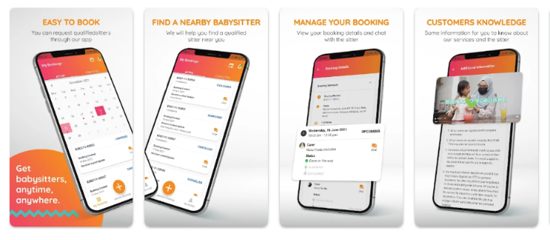
2.2.1.1 Kiddocare apps features

2.2.2 Sitty

2) Sitly is a babysitter-matching app available in Malaysia where parents can browse profiles of babysitters (or nannies) and contact them. According to its description, parents can filter by location, check experience and references, then chat with the babysitters. It functions more like a community matching platform rather than a fully managed agency: the screening of babysitters is largely in parents’ hands. However, the Sitly app have include payment model & charging issues, some users complain that you must pay to chat or use full features, which can be expensive and wasteful if you don’t find a nanny quickly. “Need to pay to even chat … around RM46+/month … quite ridiculous”. In Addition, some customer feedback their service are slow response and limited matching ,“It’s a bit hard to get a suitable babysitter.” Not only that, customer also review noted babysitters not taking safety seriously, needing parents to do more vetting themselves.
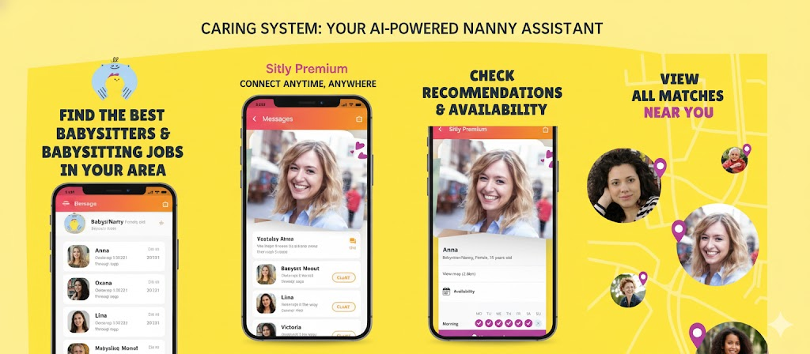
2.2.2.1 Sitly apps features

2.2.3Homage

3) Homage is a Malaysian (and regional) on-demand home caregiving platform focusing largely on elderly care and in-home nursing/support services. Although its main thrust is elderly/home health care rather than purely nanny/childcare, it overlaps your domain because it shows how care services are digitalised and app-based in Malaysia. For instance, families can book home personal care, nursing, therapy services via the Homage app. But the weakness of Homage are obviously due to them focus more on elderly/home nursing than purely nanny/childcare, which may mean less specialization for child-care situations if used for that. Then, technical issues like the FAQ indicates users sometimes face login/app/troubleshooting problems which will affect the user experience.

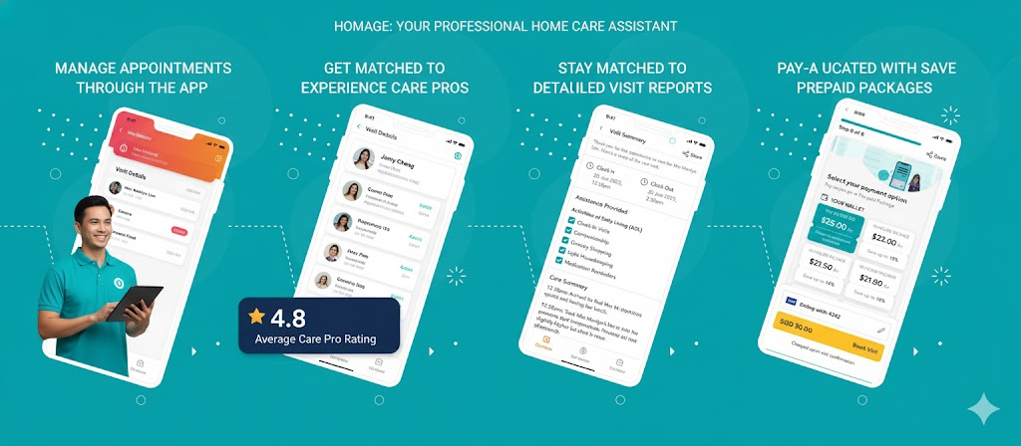
2.2.3.1 Homage apps features

2.3 Compare Between 3 Existing Systems
In this section, we are going to compare our proposed AI Nanny System “Carrying” with several existing nanny applications in Malaysia, such as Kiddocare, Sitly, and Homage. The comparison focuses on several key aspects, including the main focus, AI recommendation system, communication features, tracking system, live location, target users, payment method
By conducting this comparison, we aim to clearly identify the strengths and weaknesses of the existing systems and to highlight how our proposed system provides better security, reliability, and convenience for both parents and nannies. This also helps to justify the uniqueness and improvement of our system compared to other available platforms in the market.

2.3.1 Comparison Table
Table 2.1
Feature / Aspect | Kiddocare | Sitly | Homage | Caring
Main Focus | Childcare service for kids. | Babysitting platform connecting parents & sitters. | Elderly & medical home care. | Both Childcare and Elderly Care with AI recommendations.
Verification & Trust | ID & background check. | Limited verification; screening largely in parents’ hands. | Licensed healthcare workers. | Smart AI-based verification
AI Recommendation | - (None explicitly mentioned). | - (None explicitly mentioned). | - (None explicitly mentioned). | Smart AI recommendation based on user needs, rating, distance, and experience.
Real-Time Location Tracking | - (Not available). | - (Not available). | Care visit updates (Activity tracking). | Real-time Nanny Live Location Tracking for parents.
Live location Monitoring | - (Not available). | - (Not available). | - (Not available). | Real-time location Monitoring from user’s home (Nanny's perspective).
Communication Feature | In-app chat. | Limited (requires paid access). | In-app communication. | Secure in-app chat with real-time communication.
Payment Model | In-app payment. | Subscription model (paid access required for chat). | In-app payment. | Secure In-app Payment with record tracking.

2.4 Current Technology Used

1)React.js
React is a JavaScript library for building user interfaces. React is used to build single-page applications. React allows us to create reusable UI components.

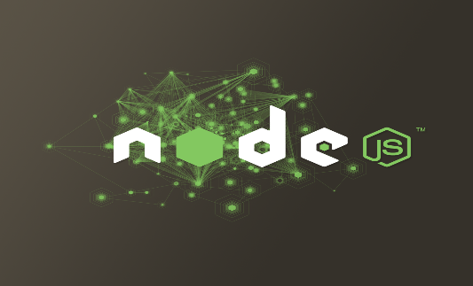
2)node.js
Node.js is a runtime environment that allows developers to build scalable backend services using JavaScript. It is commonly used to create RESTful APIs for mobile applications and is known for its high performance and non-blocking architecture.


3)Firebase
Firebase is an app development platform built by Google that offers a whole bunch of backend services to help developers quickly create high-quality web and mobile apps. It supports real-time databases, user authentication, cloud storage, push notifications, analytics, and more, and it's widely used by both startups and big companies in their app setups.

4)Flutter
Flutter is an open-source UI toolkit developed by Google that lets you build high-performance mobile, web, and desktop apps from a single codebase. It uses the Dart programming language and comes with a bunch of widgets and tools, making it easy for developers to quickly create gorgeous interfaces that run like native apps.


5)Amazon S3
Amazon Simple Storage Service (Amazon S3) is an object storage service that offers top-notch scalability, data availability, security, and performance. Use it to store, manage, analyze, and protect all sorts of data. Organize and analyse your data and set up precise access controls to meet your specific business and compliance needs and design for online backup and archiving of data and applications on Amazon Web Services (AWS).

2.5 Summary
This chapter reviews research and literature on nanny assistance systems, covering the analysis of existing systems, comparison of solutions, and an overview of the technologies used to develop these systems. To develop a new system, we selected three well-known existing systems, such as Kiddocare, Sitty, and Homage, as our research subjects. Through the study of these three systems, we not only gained insights into developing a new system but also discovered some shortcomings in existing systems. These include unresolved security issues, unprofessional nannies in some nanny systems, and some platforms charging exorbitant fees to activate the chat system, making them more like social matching platforms than nanny search platforms, thus wasting customer feedback. Furthermore, existing systems do not provide truly real-time chat; some require waiting several hours, and some even wait several weeks, to receive chat messages. Therefore, this chapter aims to lay a solid foundation for optimizing and strengthening our new system by gaining a deeper understanding of the shortcomings of existing products.

Chapter 3: Methodology

3.1 Introduction
Methodology in this project means the step-by-step way we planned and built the Caring System (Nanny). It includes choosing the right tools, development method, time planning, and how we improved the system step by step. This chapter explains how we created the system to make sure it is safe, easy to use, and helpful for parents. The system includes AI nanny suggestions, live tracking, live location, booking features, and secure chat.
To handle this big project more easily and work better as a team, we used the Agile Software Development Methodology. Agile helps us build the system part by part (called sprints), so we can test, get feedback, and improve every two weeks. It gives us more flexibility and allows us to make changes quickly if needed.

3.2 Methodology Choice and Justification
Methodology Choice: Agile methodology
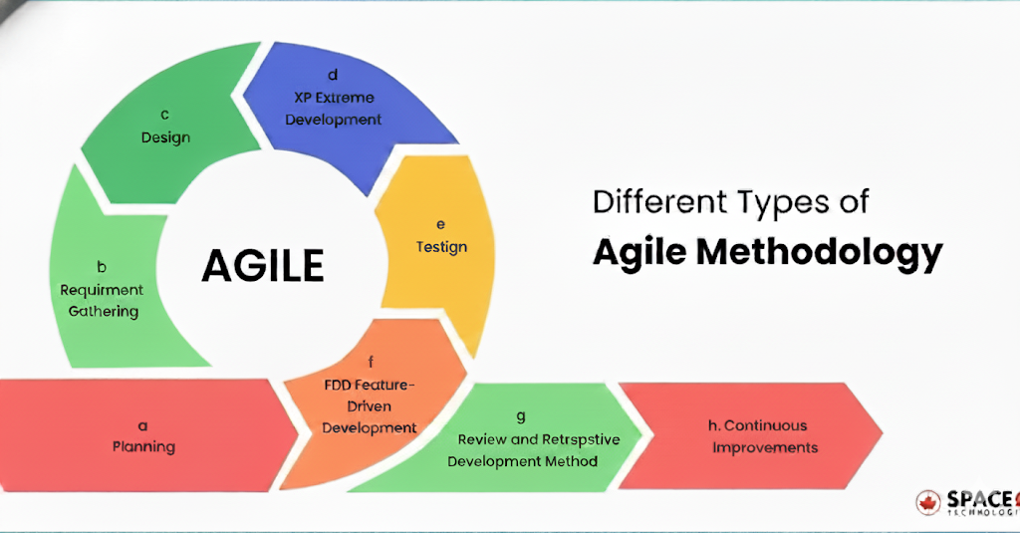

3.2.1 Agile Methodology
- Build It Piece by Piece (Iterative Development)
We don’t do “big bang” launches. Instead, we build the system step by step, delivering functional increments on a regular basis. This “bit by bit” approach is our safety net especially when it comes to complex features like AI matching and real-time safety protocols. Every single part is carefully tested and refined before the next one begins, making sure each feature rests on a stable, rock-solid foundation of security and performance.
- We Listen Constantly (Customer Collaboration)
Our users aren’t just people who download an app that they’re our trusted co-creators. We keep communication open and ongoing with families and caregivers to understand what’s truly working and where friction exists. Because our system’s intelligence and trustworthiness depend entirely on user behavior and honest feedback, this two-way collaboration is absolutely essential. It’s the engine that powers smarter AI, safer service, and a platform that’s genuinely useful to real people.

- Ready for Anything (Flexibility)
In tech especially when safety and AI are involved that change isn’t a surprise, it’s inevitable. Whether it’s critical feedback, a new compliance requirement, or an unexpected insight, plans can shift in an instant. Agile gives us the structure and flexibility to pivot quickly without losing progress. It helps us learn, adapt, and improve as we go, so the final product is always stronger and more relevant to what families actually need.
- Catch Problems Early (Risk Management)
Short, focused sprints are our best defense against failure. They help us catch and squash bugs or security issues the moment they show up the long term before they grow into costly setbacks or, worse, compromise user safety. Regular testing and transparent feedback sessions keep us ahead of the curve and fully in control of our quality.
- Always Getting Better (Continuous Improvement)
We value honest reflection more than finger-pointing. After every sprint, our entire team takes a deliberate moment to ask: “What could we have done better this time?” These powerful moments of insight help us fine-tune our workflow, sharpen our processes, and deliver higher-quality results with greater efficiency in every single time we roll out a new feature.

3.3 Phases Within the Chosen Methodology/ Planning
Phase 1- Planning
Objective Setting: Define the main mission of the Nanny System, focus on creating a safe and reliable platform that facilitates match for parents and nanny.
Stakeholder Engagement: Identify and talk to key stakeholders, especially working parents and potential babysitters, to gather their needs based on the safety, tracking, and trust issues they mentioned in initial interviews.
Roadmap Creation:
Team Formation: Create a cross-functional team with software development, UI/UX design, and project management.
Resource Allocation: Allocate any necessary resources, including tools, technologies, and budget.

Phase 2- Requirements Analysis
Goal: Based on the user requirements in interview, analyse the functional requirements and design the system's comprehensive technical architecture and logical flow. For example, define a flow like 'As a parent, I want to see the babysitter's real-time location to make sure my child is safe.’
Prioritization: Based on the importance of features and their impact on user trust, attempt to determine priorities. During the initial development phase, core security features like nanny verification and AI recommendations were prioritized over secondary features like rating systems and chat functionality.
Backlog Creation: Create a product backlog with prioritized user stories and tasks.

Phase 3 – Design
Goal: Design use cases and prototypes to understand the user interface and the functionality users need.
System Architecture: Design a robust client-server architecture where the React.js (Web) and Flutter (Mobile) frontends communicate with the Node.js backend via a RESTful API. This ensures a smooth data flow between the user interface and the server.
Technical Specifications: Develop detailed technical specifications for each component, such as real-time live location monitoring and secure payment integration.

Phase 4 - Development (Sprints)
- Sprint 1 - Develop the management module to manage the registration, authentication and role selection of user
- Sprint 2 - For User Safety, implement user profile settings, supporting document uploads and verification status updates.
- Sprint 3 - Based on user search and matching module, implement artificial intelligence and search functions, build a integrate AI logic like recommend nanny based on user location.
- Sprint 4 - Develop a secure chat communication module for user and integrate real-time location and live location monitoring functions to fulfil user requirement.
Phase 5 – Testing
Testing: Conduct Unit Testing and Integration Testing at the end of every sprint to find and fix bugs early. User Acceptance Testing (UAT) is performed to verify that features like "Real-time AI matching" meet the specific needs identifdie
Deployment: Deploy the fully functional application to the live environment using cloud hosting services.
Review & Maintenance: Monitor the system for issues such as app crashes and collect the feedback of user for future continuous improvement.
By following the Agile Software Development Methodology , the development of the Caring System can be managed efficiently, to ensure that the final product match the main needs of user This iterative approach allows for the systematic integration of complex features like AI recommendations and real-time monitoring, ultimately delivering a seamless, transparent and trustworthy caregiving experience for both families and nannies.

3.4 Technology / Tools Used

1) GitHub
GitHub is a web-based platform that uses Git software and allows developers to create, store, manage, and share their code. It provides a distributed version control system and access control, bug tracking, software feature requests, task management, social coding, integration and automation, and wikis for every project.

2) Visual Studio Code
Visual Studio Code (VS Code) is a free, open-source code editor developed by Microsoft for Windows, Linux, macOS, and web browsers. Its features include debugging, syntax highlighting, intelligent code completion, snippets, code refactoring, and embedded version control with Git.

3)Node.js
Node.js is a runtime environment that allows developers to build scalable backend services using JavaScript. It is commonly used to create RESTful APIs for mobile applications and is known for its high performance and non-blocking architecture.
4)Firebase
Firebase is an app development platform built by Google that offers a whole bunch of backend services to help developers quickly create high-quality web and mobile apps. It supports real-time databases, user authentication, cloud storage, push notifications, analytics, and more, and it's widely used by both startups and big companies in their app setups.
5）Flutter
Flutter is an open-source UI toolkit developed by Google that lets you build high-performance mobile, web, and desktop apps from a single codebase. It uses the Dart programming language and comes with a bunch of widgets and tools, making it easy for developers to quickly create gorgeous interfaces that run like native apps.

3.5 System Requirements Analysis

3.5.1 Hardware
Item Requirement | Description
Smartphone | Ios 18.6.2  Android 15
Laptop | Windows 11

3.5.2 Software
Item Requirement | Description
Developer Tools | - Visual Studio Code
Programming language | - HTML  - JavaScript
Database | - SupaBase
Framework | - React Native
Design Tools | - Canva
Api | - RESTful Api
Server | - Node.js
AI processor | - Google tensor g5
Testing | - React Native

3.6 Gantt Chart
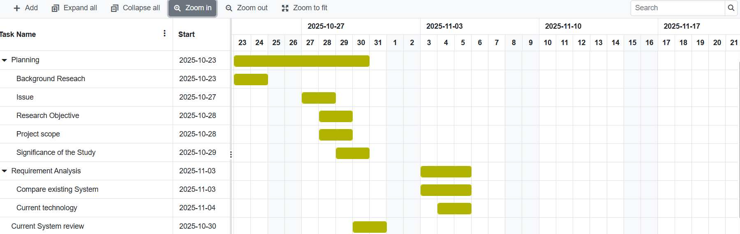
Figure 3.6.1 Gantt Chart-1
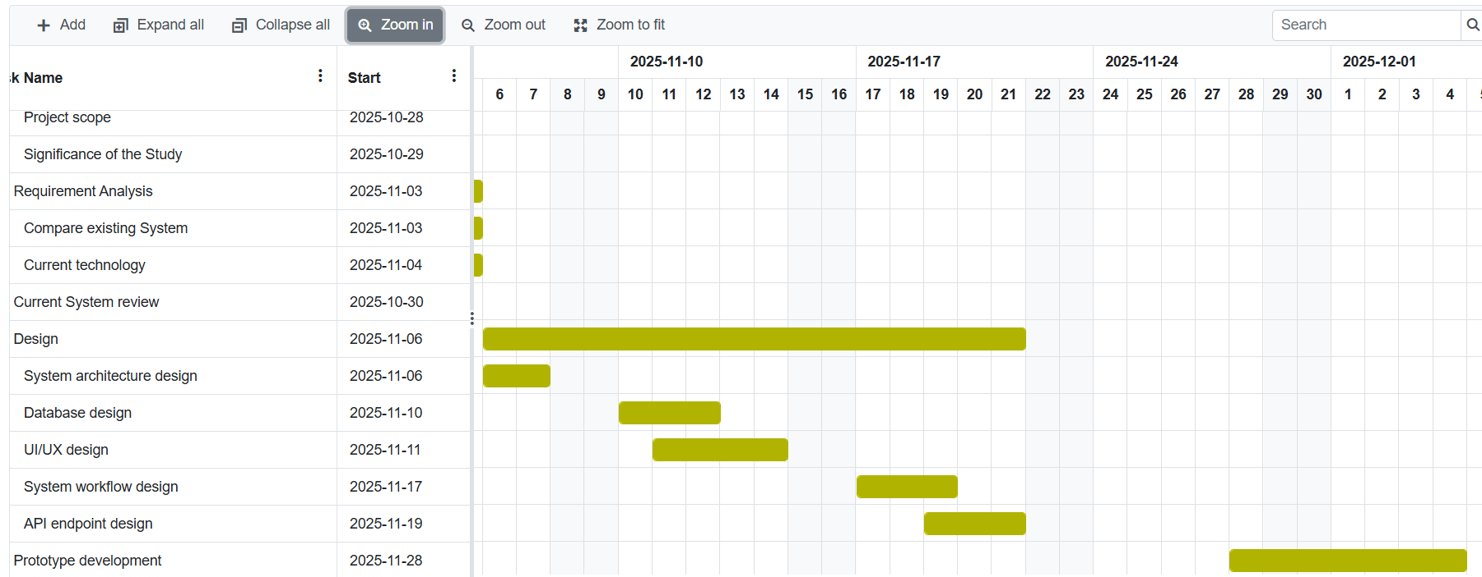
Figure 3.6.2 Gantt Chart-2

3.7 Financial Justification
WBS Items | Unit/  Hours | Unit/Cost | Subtotals | Totals
1. Project Management  -Project Manager  -Programmer | 1  2 | RM 6000.00  RM3000.00 | RM6000.00  RM6000.00 | RM 12000.00
2. Hardware  -Phone  - iOS 18.6.2  - Android 15  -Laptop  - Windows 11  -Server  - Storage: 2TB/month | 1  2  3  1 | RM4000.00  RM3500.00  RM3500.00  RM100.00 | RM4000.00  RM7000.00  RM10500.00  RM100.00 | RM 21600.00
3. Software  - Microsoft Office | 1 | RM 359.00 | RM 359.00 | RM 359.00
4. Training & Support  - Project Team Member | 1 | RM300.00 | RM300.00 | RM 300.00
5. Reserve (20% of Total Estimate) |  |  |  | RM 6851.80
Total Project Cost Estimation |  |  |  | RM 41110.80

3.8 Summary
This approach employs an agile development model to ensure the flexibility, iterative development, and continuous improvement of the nanny service system. Through structured phases such as planning, requirements gathering, design, development, testing, review, deployment, and continuous improvement, the system can be built efficiently while meeting user expectations for security, functionality, and reliability. Modern technologies such as GitHub, Visual Studio, Node.js, React, and Expo are used to support the system's scalability, real-time performance, and secure data processing.

Chapter 4: Design

4.1 Introduction
This section provides an overview of the system design phase, during which the development team defines the system's functions and other details. The main task of this phase is to introduce the tools used, including Data Flow Diagrams (DFDs) and Unified Modeling Language (UML) diagrams, such as Entity-Relationship Diagrams (ERDs), Use Case Diagrams, Use Case Descriptions, Class Diagrams, and Activity Diagrams. These tools are used to specify the system's modules, components, and data to meet predetermined requirements. Through this process, the development team can create a comprehensive blueprint for system construction and integration, ensuring that all aspects are coordinated.

4.2 Use case diagram

4.2.1 Overall Nanny System
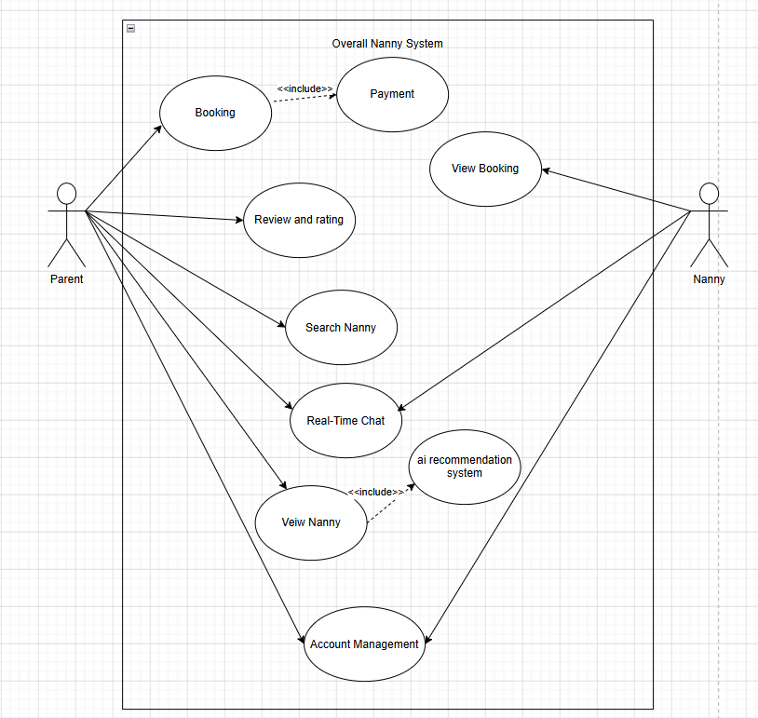
Figure 4.2.1 Use Case Diagram Overall Nanny System

Parent | Nanny
1) Manage Account (register, login, edit profile)  2) Searching and Booking nanny  3) Give Review and rating  4) real-time chat  5) payment | 1) Manage Account (register, login, edit profile)  2) View booking detail  3) real-time chat

4.2.2 User Account Management
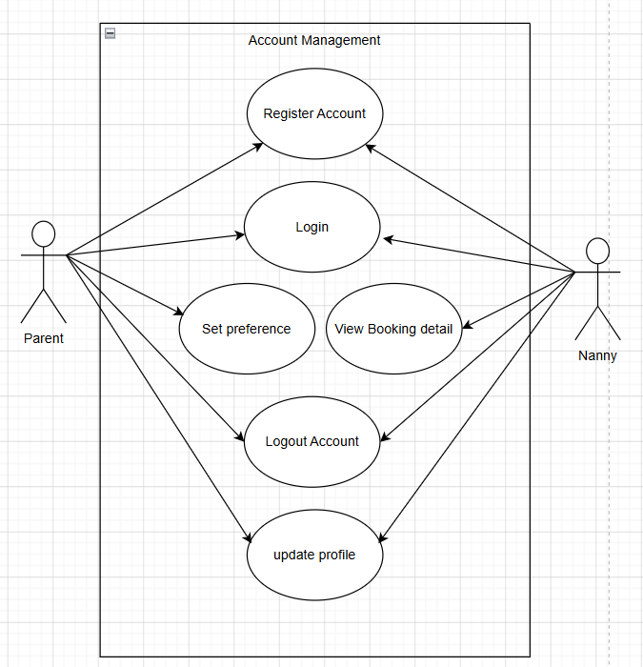

Figure 4.2.2 Use Case Diagram User Account Management
Use case | Register account
Overview | Parents and Nanny register account to the system
Pre-condition | Parents and Nanny need to have email address
Post-condition | Parents and Nanny successfully registered an account
No | Event | Response
1 | Open the app or web, then click “register” | Show the registration form
2 | Fill up information and create password | Validate the date
3 | Click “submit” button | Successfully registerd account and redirect to login page
No | Extension
1 | Invalid email address | Display an error message and ask user to re-enter the email address
2 | Invalid password | Display an error message and ask user to enter a password that fulfil the requirement (8 characters)

Use Case | Log in account
Overview | Parents and Nanny log in account
Pre-condition | Parents and Nanny successfully registed an account
Post-condition | Parents and Nanny successfully log in to the system
No | Event | Response
1 | Open the app, then click “login” | Show the login page
2 | Enter email address and password | Validate the data
3 | Click “submit” button | Successfully login to the system and go to home page
No | Extension
1 | Invalid email address and incorrect password | Display an error message and ask user to re-enter the email address

Use Case | Update profile
Overview | Parents and Nanny update profile
Pre-condition | Parents and Nanny must log in to the system
Post-condition | Parents and Nanny successfully updated profile
No | Event | Response
1 | Open “profile” page in the app or web | Show the profile page
2 | Click “edit” and change the information that want to be updated | Show a form for user to fill up
3 | Click “save” button | User account information is updated successfully
No | Extension
1 | Invalid information | Display an error message and ask user to re-enter the information

Use Case | Reset password
Overview | Parents and Nanny change password
Pre-condition | Parents and Nanny must log in the system
Post-condition | Parents and Nanny successfully reset password
No | Event | Response
1 | Open “profile” page in the app or web | Show the profile page
2 | Click “reset password” | Show a form for user to enter new password
3 | Click “Save” button | Account password is changed successtully
No | Extension
1 | Existing password is same as the new password | Display an error message and ask user to re-enter the password

Use Case | Set preferences
Overview | Parents set preferences
Pre-condition | Parents must log in to the system
Post-condition | Customer successfully set preferences
No | Event | Response
1 | Parents open “profile” page in the app | Show the profile page
2 | Parents click “set preferences” | Show a form for customers to choose their preferences
3 | Parents click “OK” button | Parents preferences is stored successfully
No | Extension
1 | None

Use Case | Log out account
Overview | Parents and Nanny log out account
Pre-condition | Parents and Nanny must log in to the system
Post-condition | Parents and Nanny successfully log out from the system
No | Event | Response
1 | Open “profile” page in the app or web | Show the profile page
2 | Click “log out” | Show an alert message in a pop up window
3 | Click “yes” button | User log out account
No | Extension
1 | Click “No” | User will not log out account

Use Case | View booking details
Overview | Nanny view the booking details
Pre-condition | Nanny must log in to the system
Post-condition | Nanny successfully received order booking
No | Event | Response
1 | Nanny open the order page in the app | Show order detail
2 | Nanny click “accept” button | Show parents details
No | Extension
1 | Nanny click “decline” | Cancel the ordering

4.2.3 Review and Rating Management
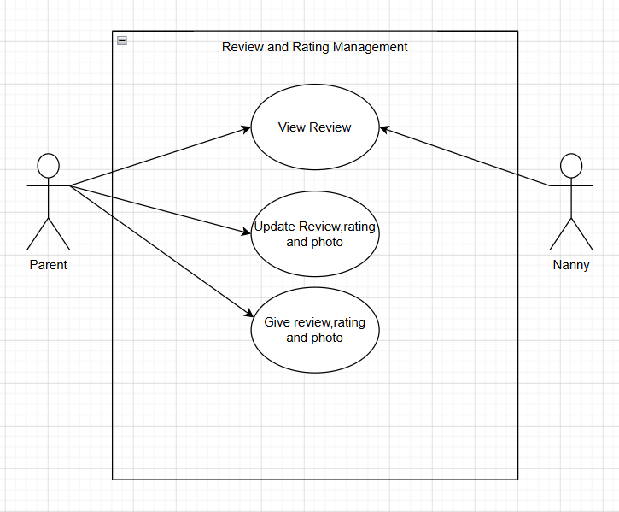
Figure 4.2.3 Use Case Diagram Review and Rating Management

Use Case | View review and update review and rating
Overview | check review and rating
Pre-condition | User must log in to the system
Post-condition | User successfully check the review and rating
No | Event | Response
1 | Customer can view the review to selecting the nanny | Show the list of review
2 | Customer can update the review and rating to updating the review | Showing the new review and rating
No | Extension
 | None

Use Case | Give review and rating
Overview | Users can write reviews, choose whether to upload photos, and give ratings.
Pre-condition | Customer must log in to the system and choose a specific nanny
Prost-condition | Customer write review and give rating successfully
No | Event | Response
1 | Customer click “comments” | Show a form of comment section
2 | Customer write review, choose whether to upload photos and give rating, then upload it | Show the review and rating
NO | Extension
 | None

4.2.4 Chat System Management
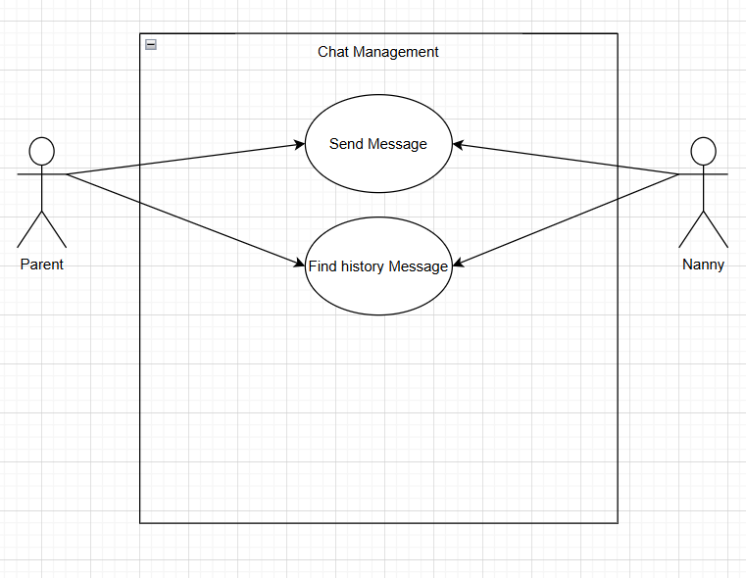
Figure 4.2.4 Use Case Diagram Chat System Management

Use Case | Send Message
Overview | Customer and nanny have a chat after the registration
Pre-condition | Customer have to booking the nanny and the nanny accepted the booking request
Post-condition | Customer can start a chat with nanny
No | Event | Response
1 | Open the app, then start a chat | Successful send the message
No | Extention
 | None

Use Case | Find history message
Overview | Customer and nanny can find their chat history
Pre-condition | Customer must booking the nanny and nanny accepted the booking request
Post-condition | Customer and nanny successful find the message history
No | Event | Response
1 | Customer or nanny click at the chat box | Show the chat
2 | Customer or nanny looking back to the chat | Show the history message
3 | Customer or nanny find the message using keyword | Show the specific history message that similar or same with the keyword
No | Extension
 | None

4.2.5 AI Recommendation
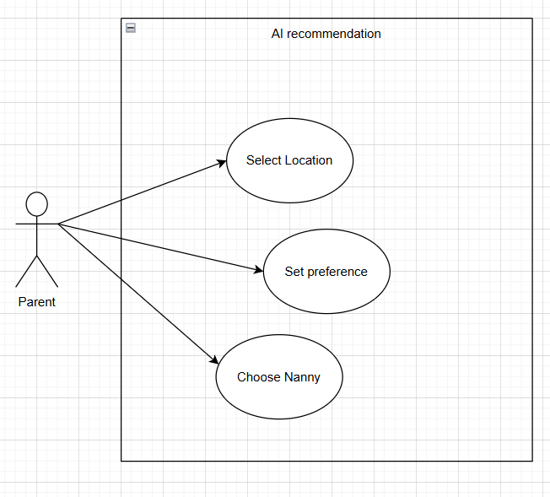
Figure 4.2.5 Use Case Diagram AI Recommendation

Use Case | Select Location
Overview | Customers select the location
Pre-condition | Customer must log in to the system and choose a specific location
Post-condition | AI successfully recommend the nanny at the specific or nearby nanny position
No | Event | Response
1 | Customer open home page in the app | Show home page
2 | Customers click “nanny recommendation” | Show a list of nanny that customer preferences
3 | Customers select their location | Show a nearest nanny at that location
No | Extention
 | None

Use Case | Set preferences
Overview | Customer select preferences
Pre-condition | Customer must log in to the system
Post-condition | Customer successfully select preferences
No | Event | Response
1 | Customer open homepage in the app | Show home page
2 | Customer click “set preferences” and enter information | Show a form for customer to select their preferences
3 | Customer click “save” button | Customer preferences is stored successfully
No | Extention
1 | Invalid information | Display an error message and ask customer to re-enter the information

Use Case | Choose Nanny
Overview | Customer obtain nanny recommendation
Pre-condition | Customer must log in to the system
Post-condition | Customer obtain nanny recommendation and choose Nanny
No | Event | Response
1 | Customer open home page in the app | Show home page
2 | Customers click “nanny recommendation” | Show a list of nanny that customer preferences
3 | Customer choose nanny that meet customer requirements | Customer view nanny that meet customer requirements
No | Extention
 | None

4.3 Class Diagram
Figure 4.3 Class Diagram

4.4 Entity Relationship Diagram （ERD）
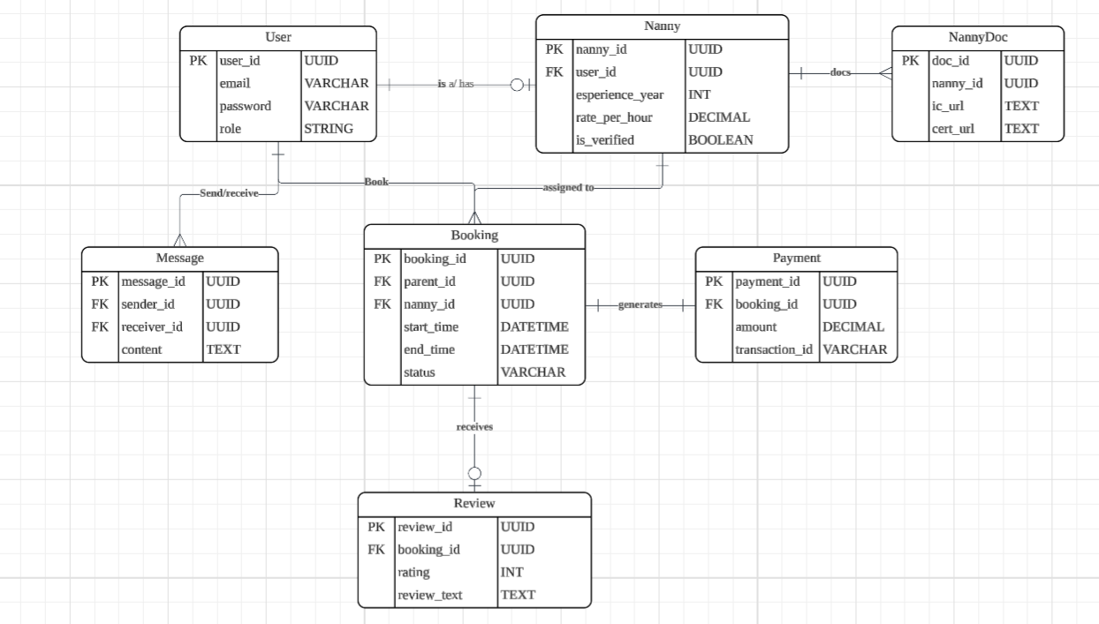Figure 4.4 Entity Relationship Diagram

4.5 Data Flow Diagram (DFD)

4.5.1 Context Level
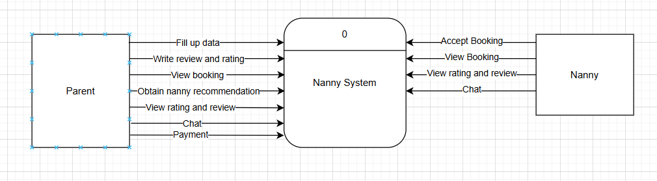
Figure 4.5.1 DFD Context Level

4.5.2 DFD Level 0
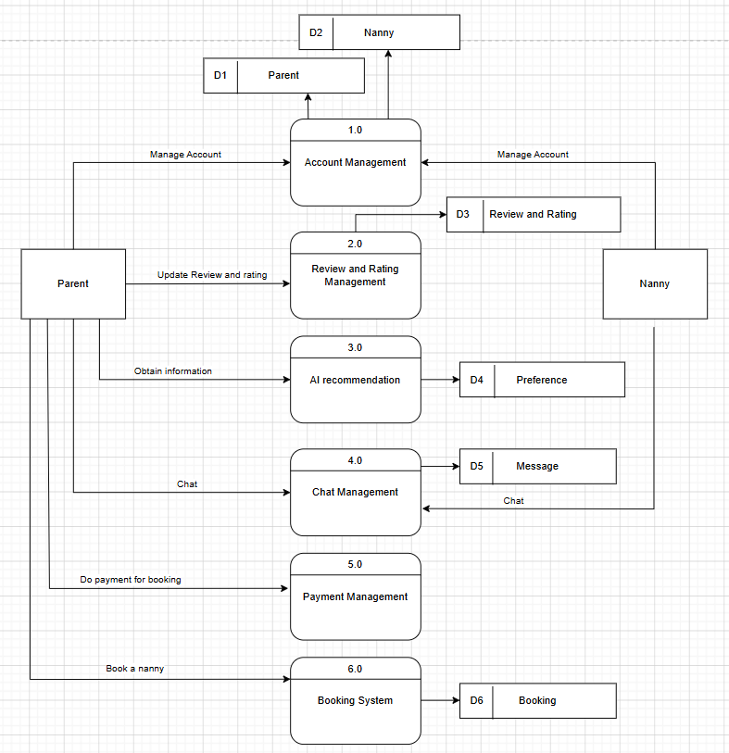
Figure 4.5.2 DFD Level 0

4.5.3 Level 1
Account Management Module
-Parent
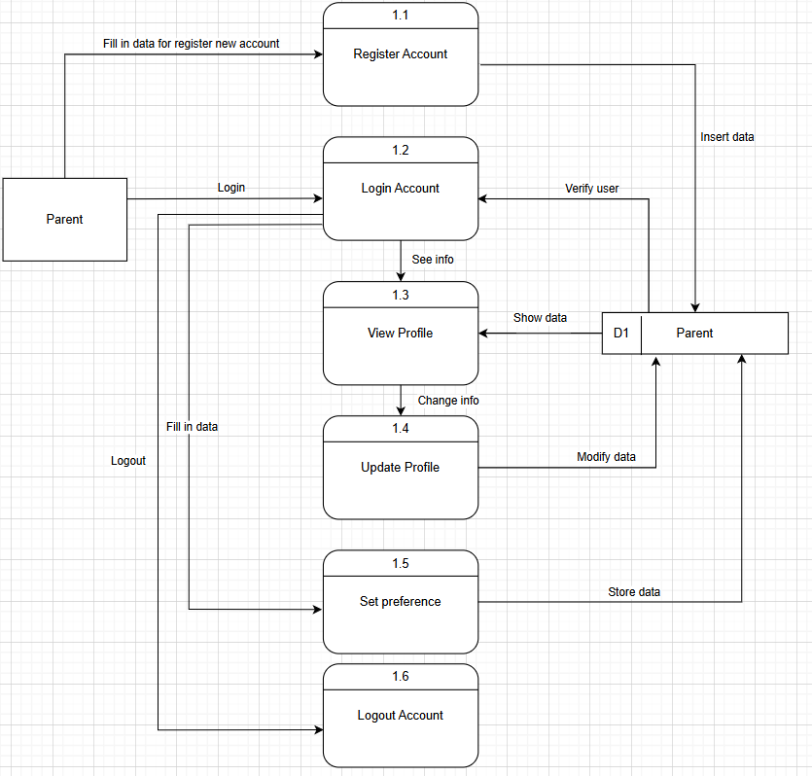
Figure 4.5.3.1 DFD Level 1 Parent Account Management Module

-Nanny
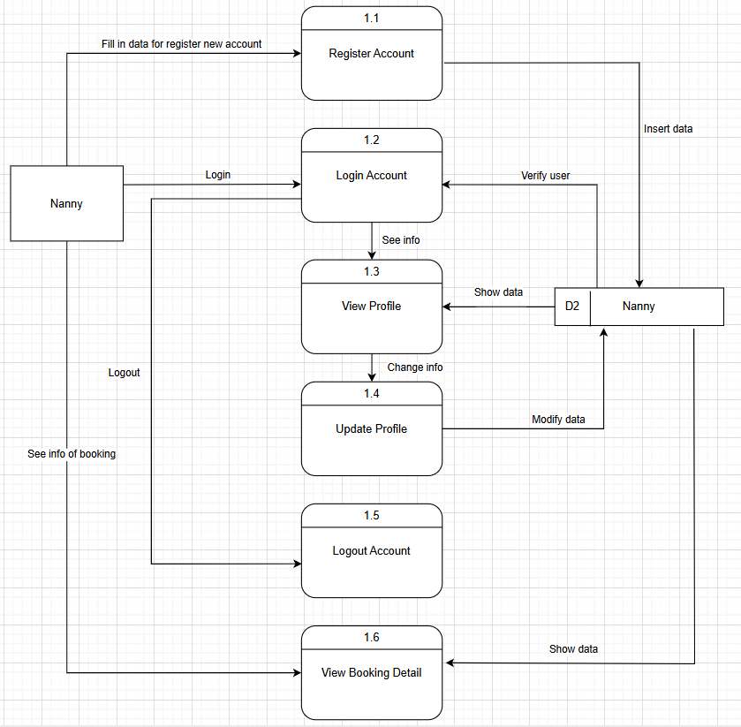
Figure 4.5.3.2 DFD Level 1 Nanny Account Management Module

Review and rating management
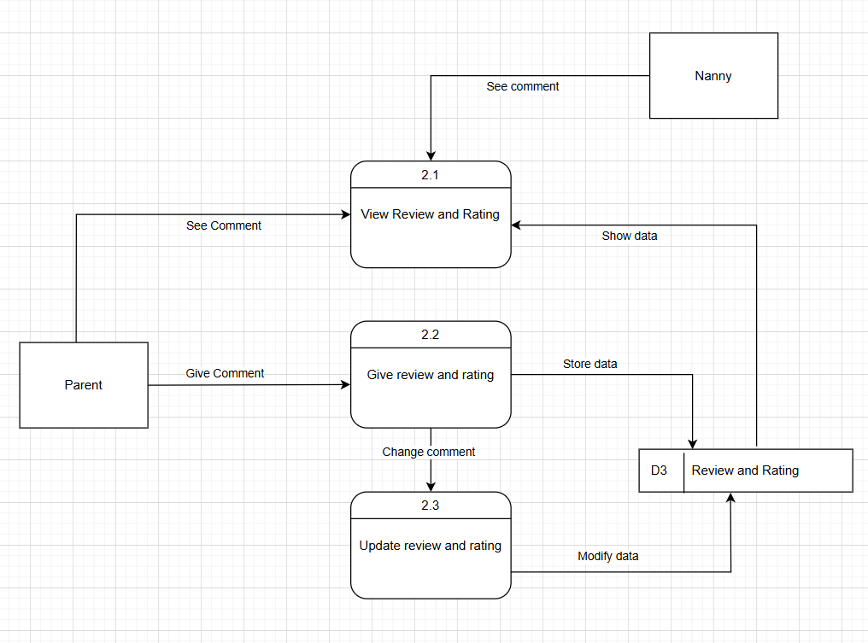
Figure 4.5.3.3 DFD Level 1 Review and Rating Management

Chat System Management Module
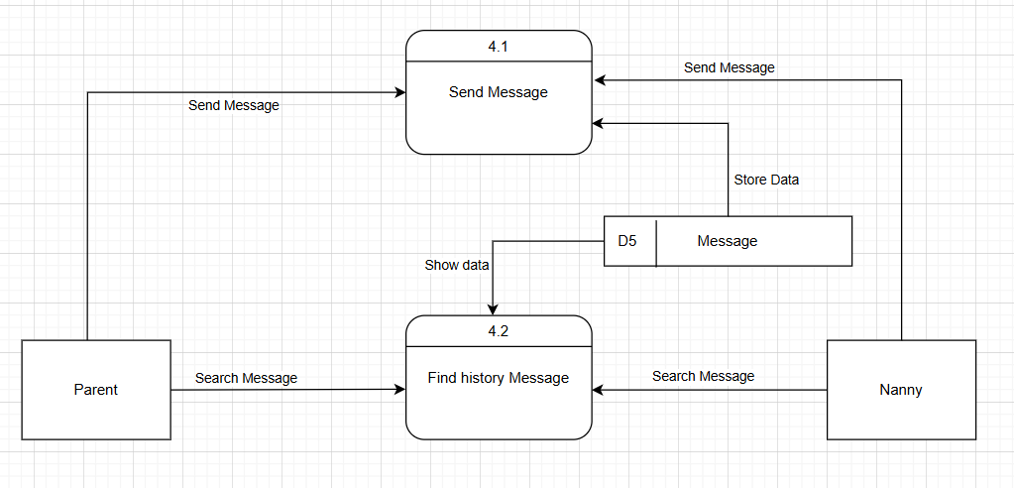
Figure 4.5.3.4 DFD Level 1 Chat System Management Module

Nanny Recommendation Module
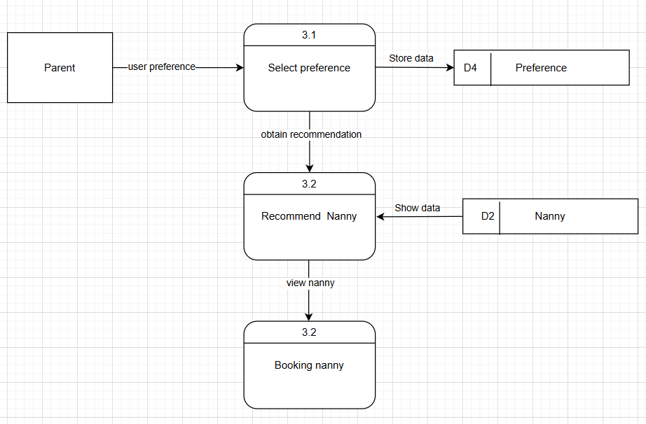
Figure 4.5.3.5 DFD Level 1 Nanny Recommendation Module
Booking Module
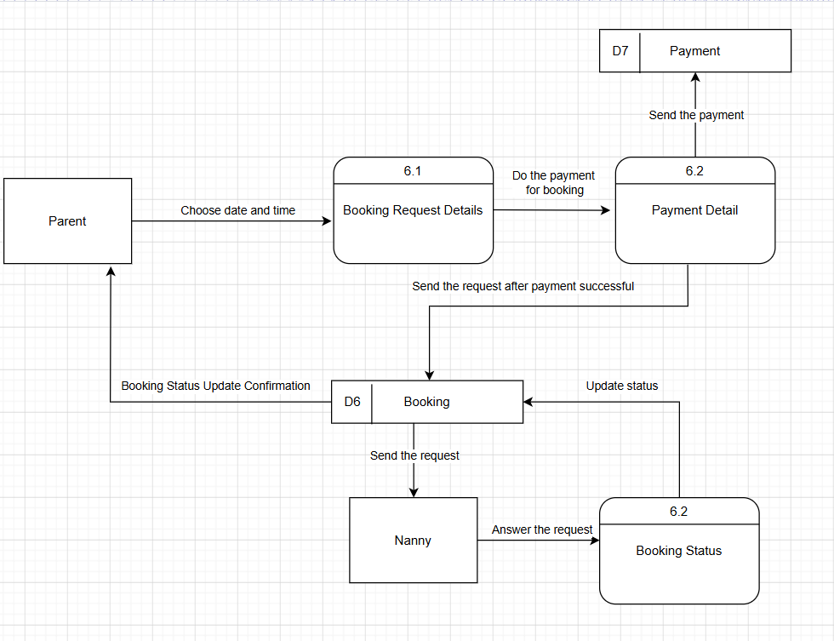Figure 4.5.3.6 DFD Level 1 Nanny Recommendation Module

4.6 Activity Diagram
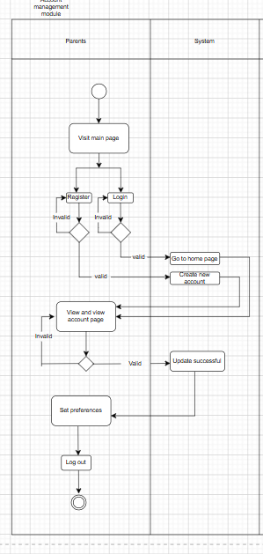
Figure 4.6.1 Activity Diagram Account Management Module

Nanny Recommendation Module
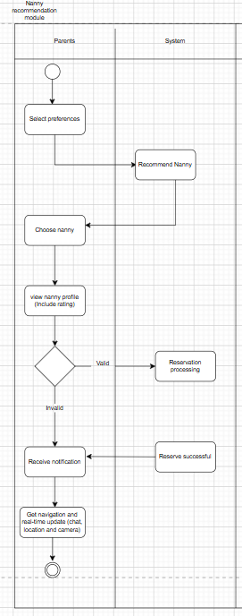
Figure 4.6.2 Activity Diagram Nanny Recommendation Module

Comment Management Module
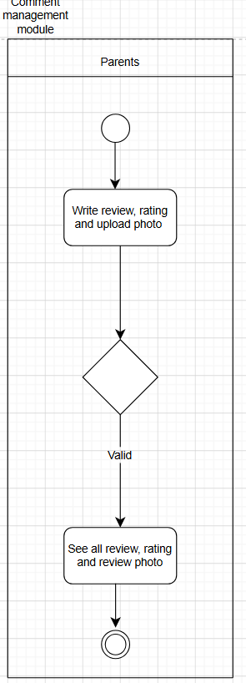
Figure 4.6.3 Activity Diagram Comment Management Module

4.7 System Architecture (Prototype)

4.7.1 Parent
Login Page
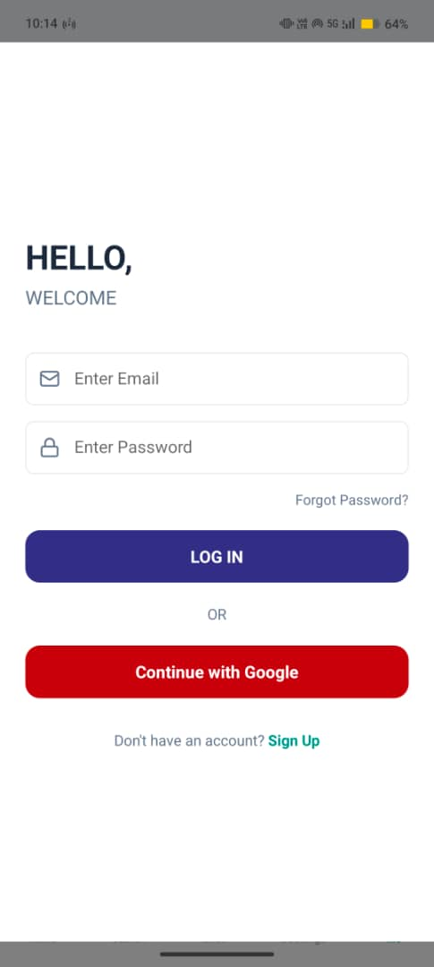
Figure 4.7.1.1 Login Page

Signup Page
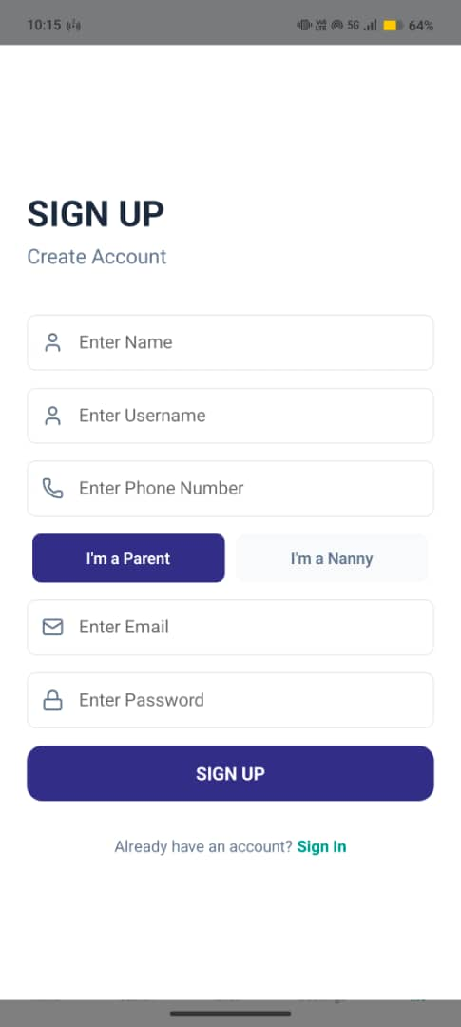
Figure 4.7.1.2 Parent Signup Page

Set Basic Preferences
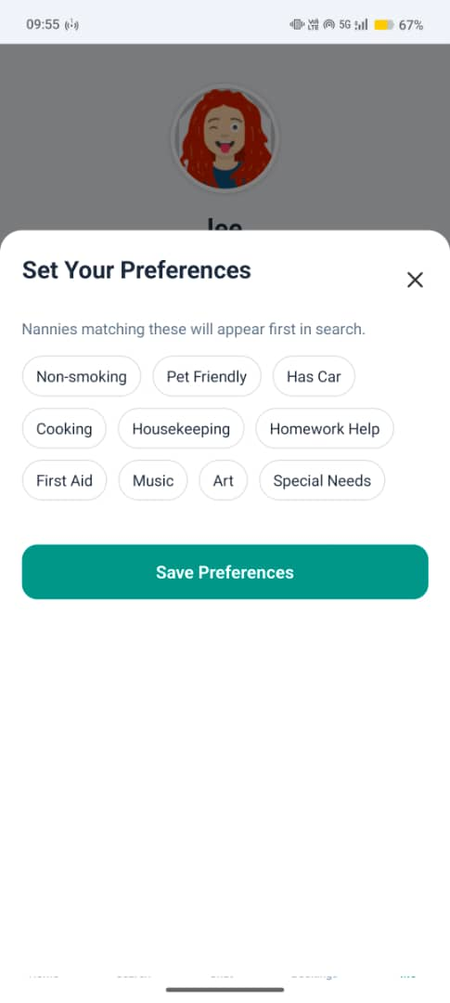
Figure 4.7.1.3 Set Preference Page

Home Page
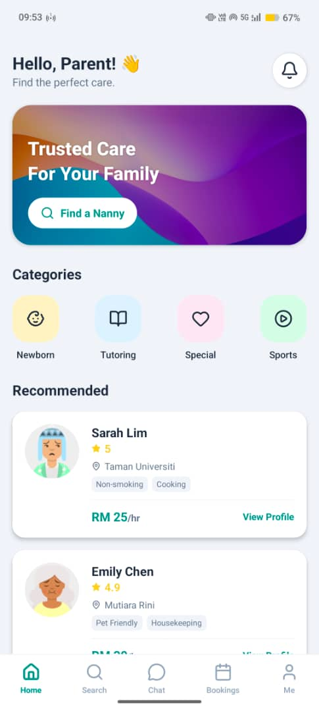
Figure 4.7.1.4 Parent Home Page

Search Page
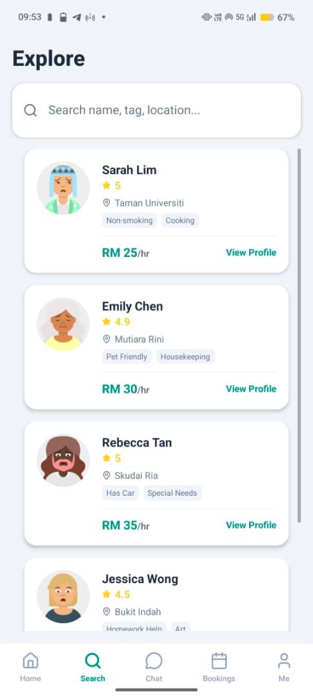
Figure 4.1.7.5 Search Page

View Nanny Profile
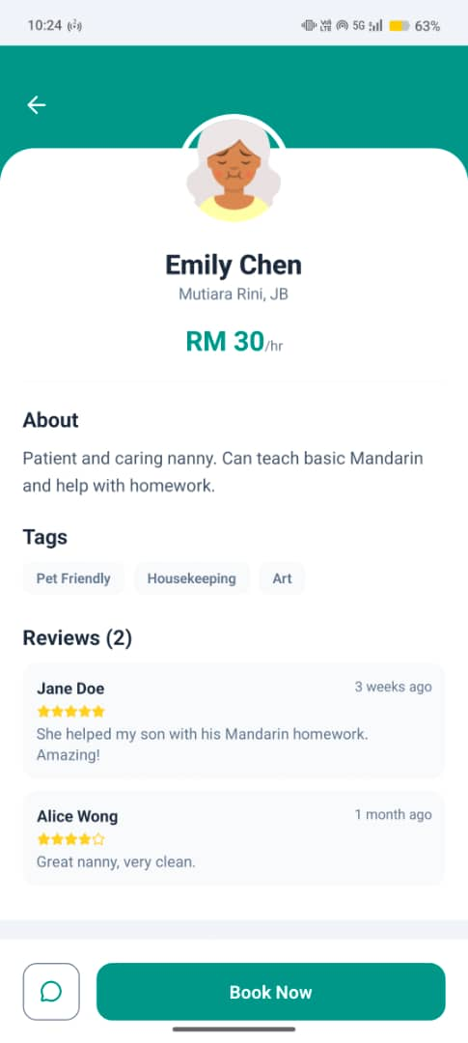
Figure 4.7.1.6 Nanny Profile

Booking detail
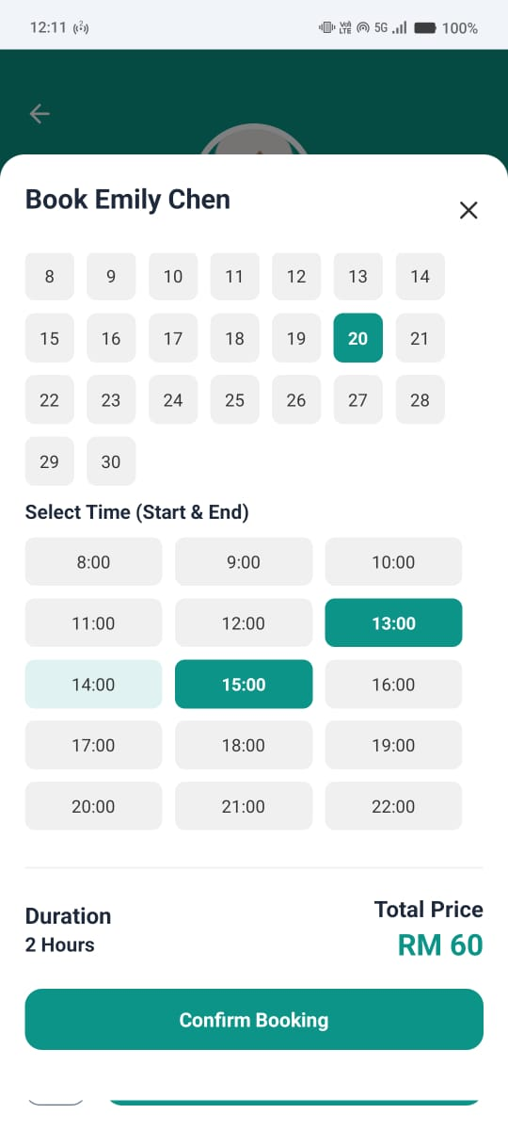
Figure 4.7.1.7 Booking Detail

Chat page
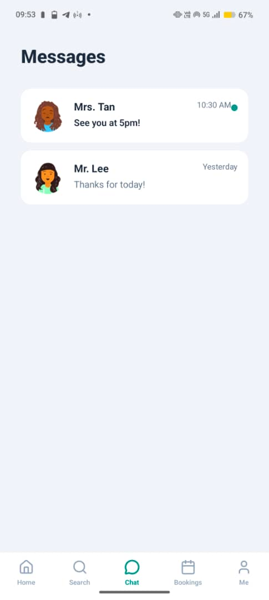
Figure 4.7.1.8 Chat Page

Booking page
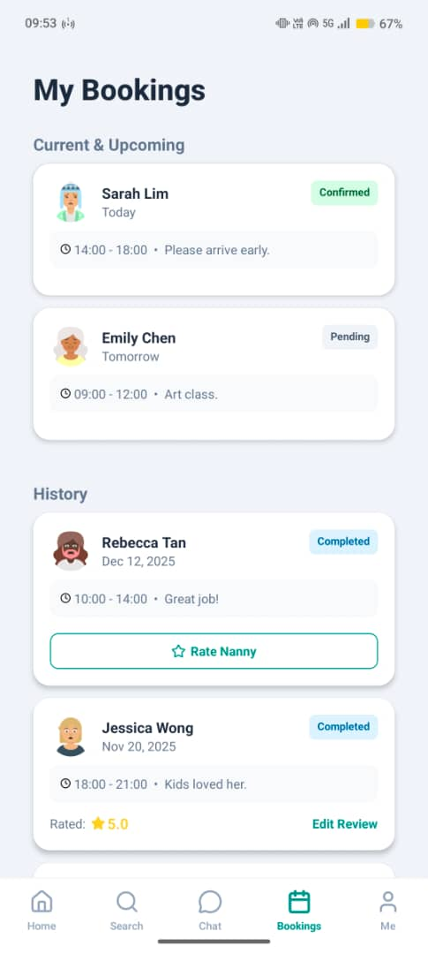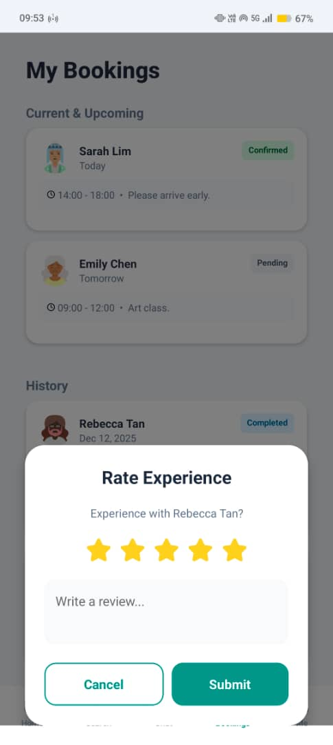
Figure 4.7.1.9 Booking Page

Profile Setting Page
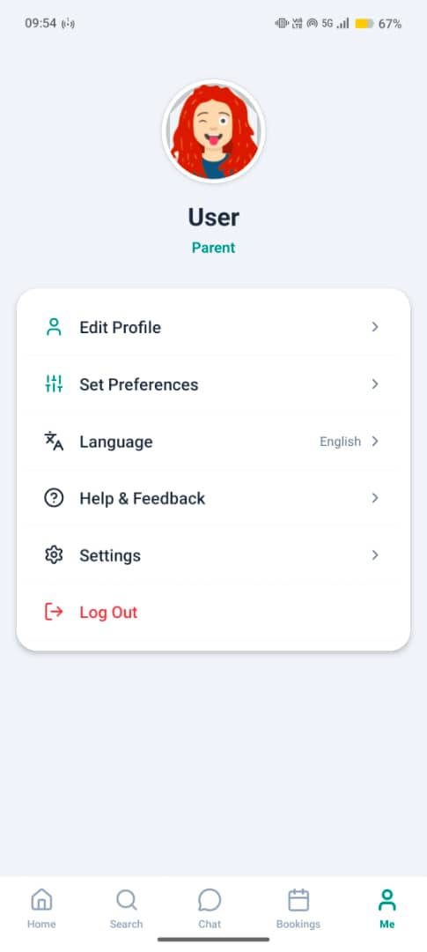
Figure 4.7.1.10 Profile Page

4.7.2 Nanny
Home page
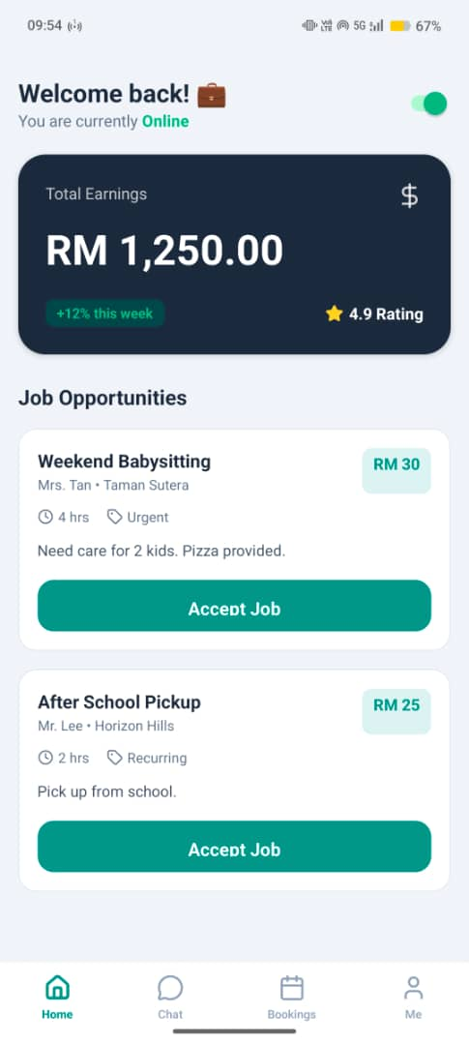
Figure 4.7.2.1 Nanny Home Page

Chat Page
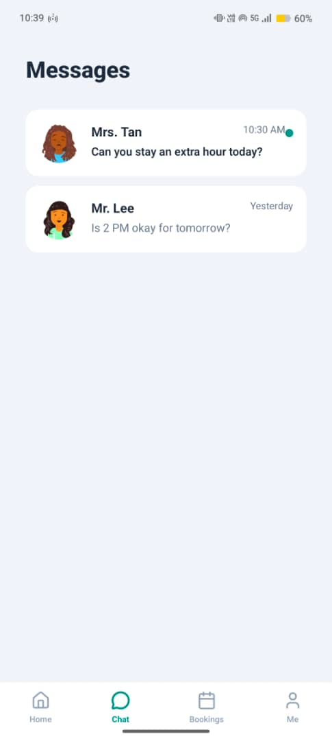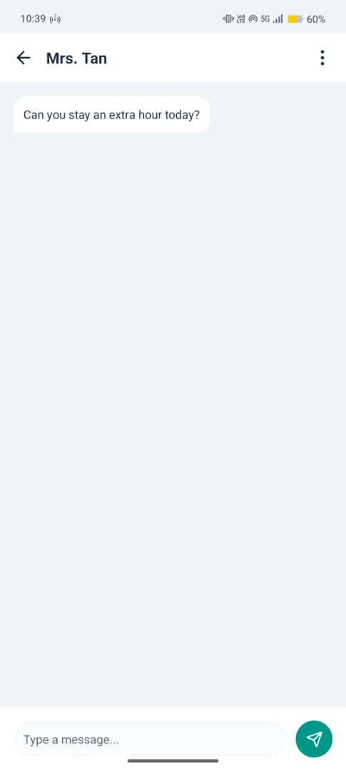
Figure 4.7.2.2 Chat Page

Booking Page
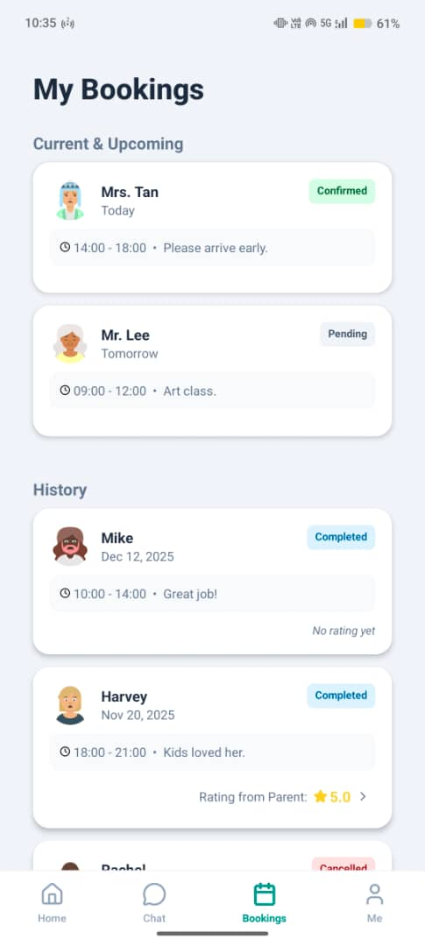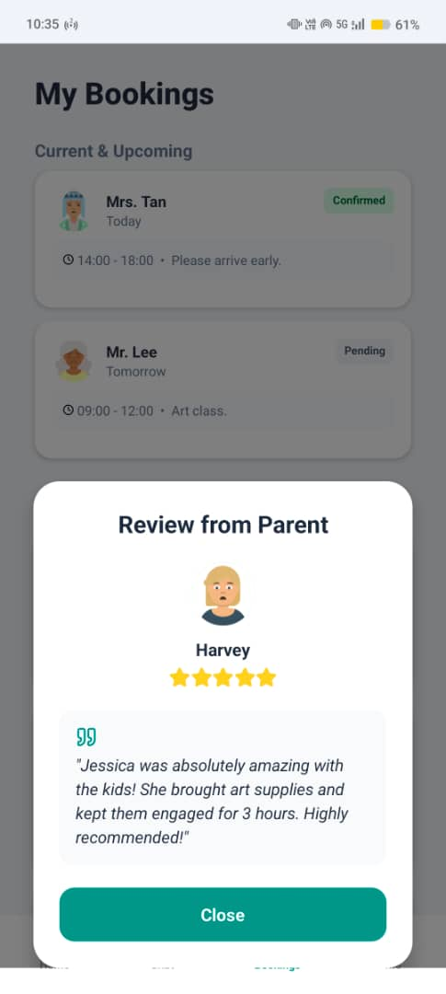
Figure 4.7.2.3 Booking Page

4.8 Summary
In short, by visualizing the system design, the development team can not only understand the architecture and components of the system more clearly, but also simplify the development process and make it more intuitive and efficient. These visualization tools provide the team with clear guidance and reference, helping to ensure the smooth implementation and seamless integration of the system.

Chapter 5: Implementation, Testing , Analysis or Evaluation

5.1 Introduction
In this section are focuses on the practical implementation of the “Nanny System (Caring)”, detailing the transition from design blueprint to a functional software application. The primary objectives is to provide a comprehensive overview of the technical environment, the core feature implementation, and the rigorous testing strategies employed to ensure system quality and reliability. Following the development plan outlined in the methodology, this section describes how the proposed system architecture which is build upon Flutter and firebase backend that was developed. Furthermore, it presents the result of system testing and user evaluation, which is verifying that the implemented features meet the predefined functional and non-functional requirement.

5.2 Implementation
This section highlights the technical realization of the core modules in the Caring System using Flutter and Firebase. It details the code, feature and code snippets that power the system.

5.2.1 Ai Match Engine
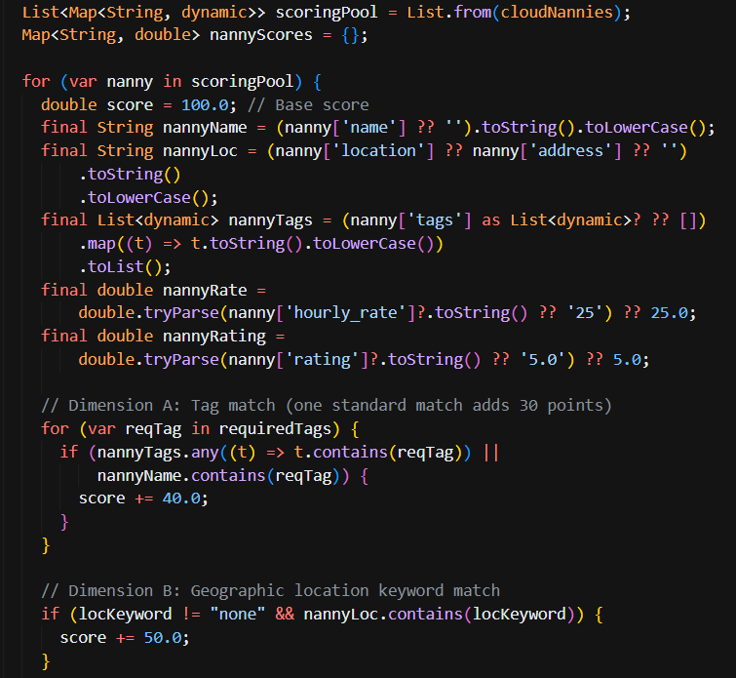
Figure 5.2.1.1 Code of AI Match Engine
The AI Match Engine uses a hybrid architecture combining Groq LLM (llama-3.1-8b-instant) for natural language intent extraction and a custom deterministic scoring algorithm in Dart. The AI will scan the nanny list database. Then, the engine will score the nanny based on their tags, add-on services, price and rating. Finally, the AI will recommend the highest-scoring nanny who best matches the user's requirements.

5.2.2 Smart Booking Engine
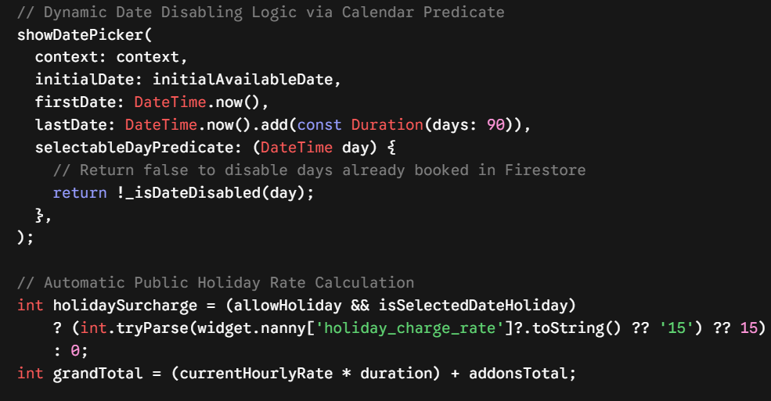
Figure 5.2.2.1 Code of Smart Booking Engine
The Smart Booking Engine is design to prevent user from repeat booking a nanny at the same time. The Engine will scan the booking database and ensure that day are not no booking. If there are booking, the engine will set the day become unselectable status. Besides, the engine will automatically detect the day is holiday or not. If the date is holiday, it will apply the holiday surcharges.

5.2.3 Rating System with Image Upload
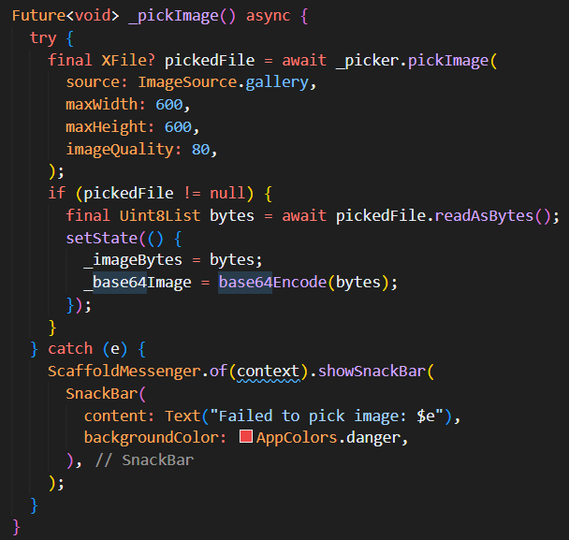
Figure 5.2.3.1 Code of Rating System
The system implements a photo review and rating module for user. The user can give a rating and review with the photo. The uploaded image will process as Base64-encoded string data. Then, it will be stored directly with the rating and review comments in Firebase Firestore. So, users and nannies can view the submitted review photos in full detail with the function full screen zoom capability.

5.3 Testing

5.3.1 Sample Population and Participant Selection
For the preliminary evaluation and beta testing phase of our Caring System (Nanny), a purposive sampling strategy was employed. The sample population which consisted of is five lecturers from Southern University College who are also active working as a parent. This target group was specifically selected to evaluate the system from a dual perspective to assessing its core functionality and user experience as parents, while leveraging their academic expertise to provide constructive, high-level feedback on the system’s usability, security features, and AI recommendation logic.

5.3.2 Automation and Performance Testing Strategies
To make our software testing process faster, more efficient and more accurate throughout the development phases, we prioritized the use of automated testing tools rather than relying solely on manual testing steps. Manual testing can often be time-consuming, repetitive, and prone to human oversight or error when checking the same features repeatedly. By using automated testing frameworks, our team was able to execute comprehensive test suites quickly and repeatedly whenever new code changes were saved. This ensured that existing features remained completely functional and free of unexpected bugs as the system expanded.
Selenium automation integration was selected and implemented as our primary tool for automated web browser testing. It acts like a real person clicking on buttons and typing text on the screen. We created Selenium test scripts to automatically check all important actions, such as registering a new user account, filling in profile details, searching for nannies, and submitting a nanny booking form to make sure every web feature works correctly.
Robot framework Acceptance Testing used as a key tool for acceptance testing because it uses simple, keyword-based test scripts that are easy to write and understand. We used it to test the main business logic and backend functions of the system. It helps us verify that processes like accepting a booking request, updating payment statuses, and sending chat messages work reliably according to the project requirements.
UI Stress test is conduct as a separate testing stage to see how well the mobile and web interfaces can perform under extreme pressure. During this test, we deliberately tested the app by tapping buttons very fast, switching screens rapidly, and simulating many users using the system at the same time. This allowed us to check if the user interface would freeze, crash, or show visual errors when the app is under heavy usage.

5.3.3 Testing Methodology & Participant Selection
To ensure the system’s stability, reliability, and usability, the testing phase was conducted in two main user-facing stages which is Alpha Testing and Beta Testing. We have total of 10 participants were selected to evaluate the system across both of the stages.
- Alpha Testing: First of the alpha testing Conducted during the initial development cycle with a controlled group of 3 participants. We are focus on identifying critical bugs, verifying database schema integrity, and ensuring end-to-end workflow execution using both mobile-simulators and physical devices.
- Beta Testing: Than for the beta testing which is the user acceptance phase, it is conducted with 10 end-users divided into two primary roles which is 5 parents and 5 nannies as our tester. That is 5 parents are simulated real-world family scenarios including nanny searching, preference filtering, booking submission, simulated payment, and reviewing. For 5 nannies, they are evaluated job request reception, decision-making which is either accept the booking or decline the booking, live chat interaction, and earning tracking.

5.3.4 Test levels & Implementation
The core software testing process was structured into three distinct technical levels which is Unit Testing, Integration Testing, and System Testing.
- Unit Testing: The main objective of unit testing is to verify the logical correctness of isolated functions, algorithms, and components without external dependencies. So, as our scope and execution is about the AI Matching Algorithm which is to test the recommendation function with mock preference inputs such as non-smoking, cooking and so on, to ensure the correct ranking weights. Than the fare and duration calculator is to validated time-span inputs such as time line 13:00 to 15:00 pm at arrange RM 30/hour, that is to ensure the total price was accurately calculated as RM60. Lastly the form input validation which is to verified regex patterns for parent or nanny emails formats and phone numbers.
- Integration Testing: The main objective of integration testing is to test data flow and interactions between multiple modules, fronted components, and backend cloud services which is in the firebase. So as our scope and execution is on the database Sync which is to verified that when a parents submits a booking, the corresponding record will updates in the database in real time. Than the real-time communication which is to tested the latency and data persistence in the app chat module using Cloud Firestore. Lastly the idempotency testing which is the action duplication prevention is to tested the system’s behaviour following the booking or payment submissions. The Ui will immediately disables the “confirm booking” or “simulated payment” button and displays a loading indicator upon the first click. This prevents duplicate API calls, duplicated payments log, or multiple booking entries caused by rapid double-clicking or network delays.
- System Testing: The main objective of system testing is to validate the complete end-to-end business process and system robustness under the multiple user operation conditions. So as our scope and execution for the end-to-end workflow execution is to tested the full parent lifecycle which is as the progress (Login$→$ Preference $→$ Explore $→$ Book $→$ Payment $→$ Chat $→$ Review) and nanny lifecycle progress (Setup$→$ Request $→$ Accept/Decline $→$ Complete $→$ Earnings). Than the stress and concurrency testing which is the clash prevention, we are having the simulated concurrent access where multiple parents attempted to book the same nanny at the same time wouldn’t cause crashing, and on the nanny side, they are able to choose which booking they want to accept.

5.4 User Guide
Nanny:
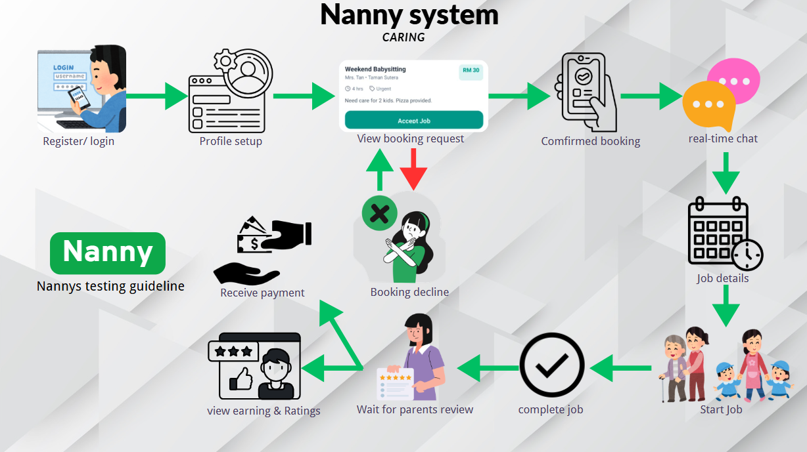
Figure 5.4.1 Nanny User Guide
Parents:
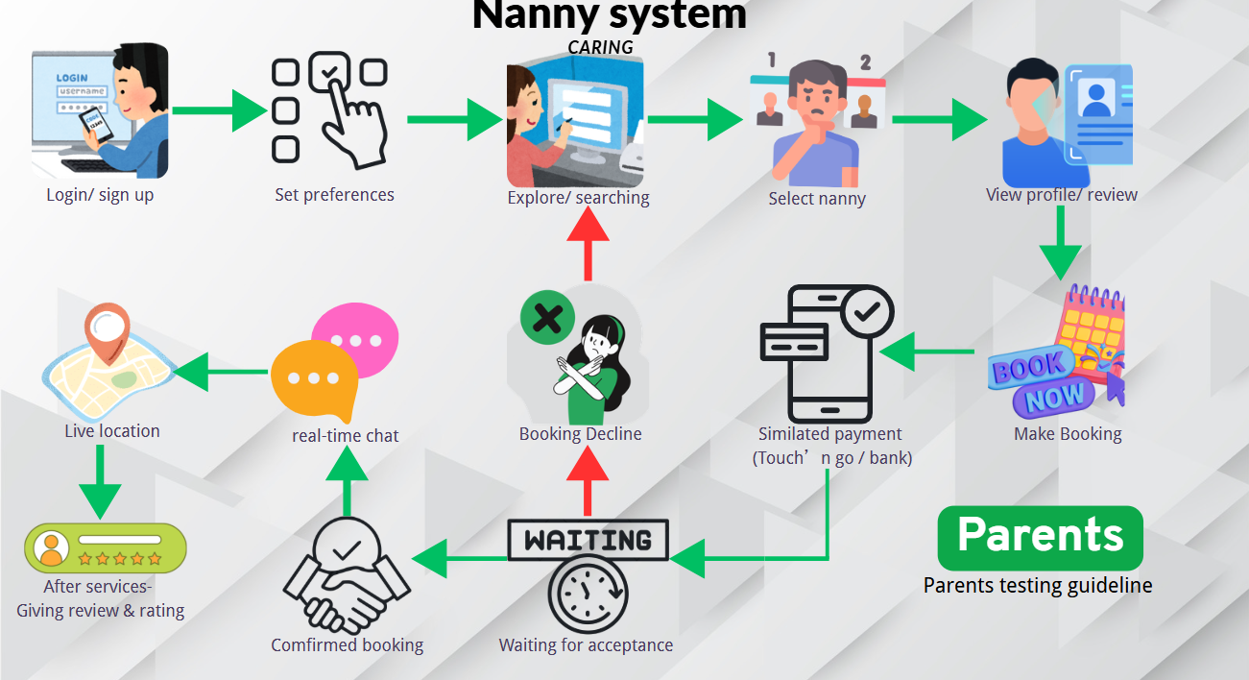
5.4.2 Manual Testing

Nanny:
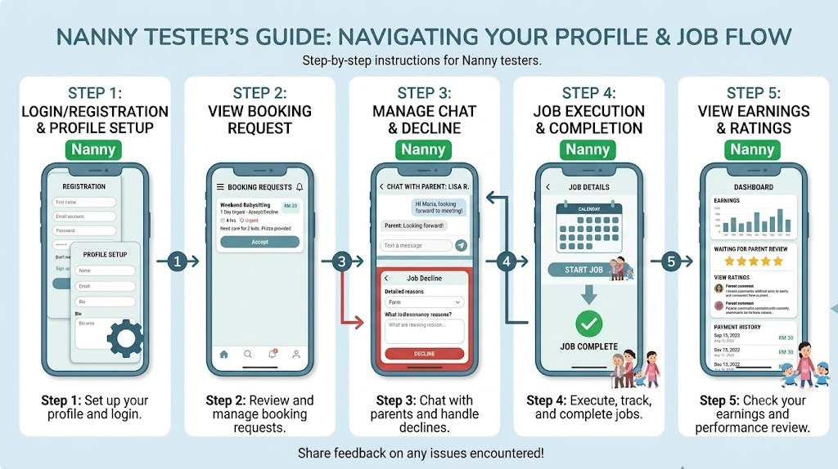

Parent:
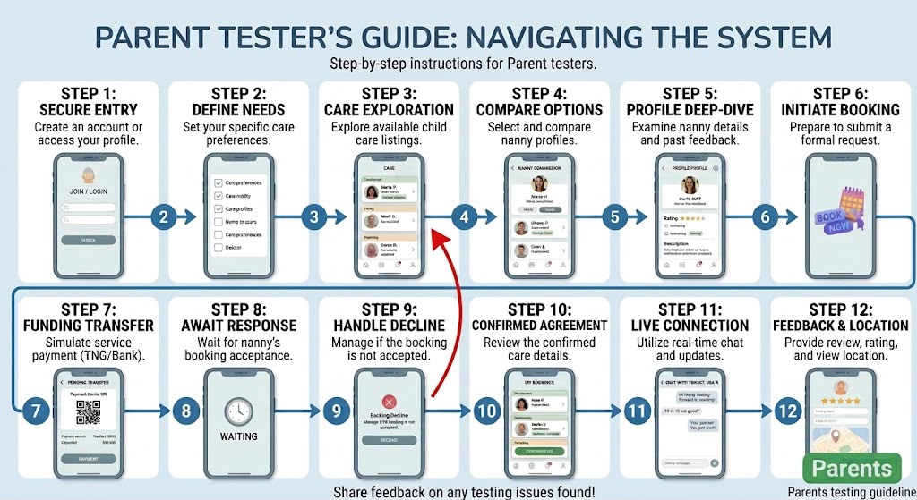

5.5 Analysis or Evaluation
5.5.1 Data visualisation: use chart / multiple category / spider chart
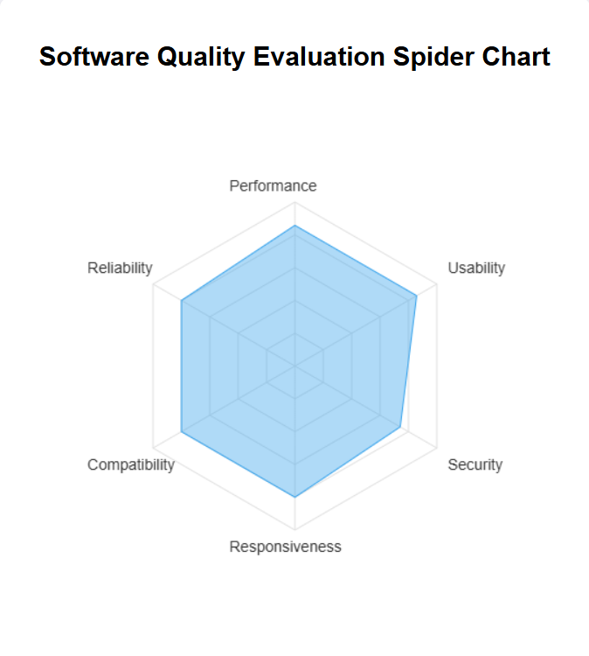
5.5.2 User acceptance test
We are receiving the user valuable feedback to in addition to quantitative metrics, qualitative recommendations were gathered to guide future iterative cycles. The user feedback focused primarily on User Experience which is the UX/UI, operation monitoring, onboarding and platform optimization.
- Enhanced real-time care verification, our users are suggested implementing a mechanism where nannies receive random system notification asking them to capture live photos or short videos of the child or elderly person under care. As the analysis, this is a high-value security feature that significantly increases transparency and reassures working parents about their family member’s safety during active service hours.
- Interactive Onboarding Wizard, our user are recommended adding an instructional wizard or step-by-step guidance for first-time users. So as our analysis we are incorporating an interactive onboarding walkthrough will lower the learning curve for non-tech-savvy parents and nannies, further boosting overall system Usability.
- Expanded mobile compatibility, our user are recommended us to make many model of mobile version that can use the app. As our analysis the future iterations should focus on extending compatibility testing to a broader spectrum of legacy mobile devices and varied screen resolutions.

5.6 Summary
In the part are detailing the practical implementation, multi-tier testing, and comprehensive evaluation of the Nanny System （Caring）. Following the Agile development lifecycle, the system was subjected to rigorous the unit testing, integration testing and including the idempotency to checks for anti-duplicate booking, and system testing which is including the concurrency clash testing. The evaluation result are comprising both quantitative and qualitative radar chart analytics and qualitative user recommendations which is demonstrate that the system successfully fulfils the core objectives of delivering an intelligent, responsive, and the user-friendly caregiving platform. While the current limitations such as simulated payments, the actionable insight gathered during the phase lay a solid foundation for future commercial-grade enhancements.

Chapter 6: Conclusion

6.1 Introduction
All in all, in this final chapter is to synthesizes the development of the “Nanny System (Caring)”, focus on summarizing the project’s key achievement, addressing current limitations, and outline recommendations for future enhancement.

6.2 Achievements
The project successfully that delivered a robust nanny management platform that integrates AI-driven recommendation logic and real-time monitoring features. Throughout this journey. We have gained technical proficiency in full-stack development, particularly in orchestrating data flows between visual studio code and firebase as a database. Furthermore, we have developed a deep appreciation for the Agile development methodology, to learning how iterative testing is to essentially for building a reliable, user-centred application.

6.3 Limitation
-Payment Integration Constraints
Due to development time and budget constraints, the current payment module of this project is a functional simulation and haven’t integrated with real third-party payment gateway APIs such as Touch 'n Go or banks. This results in users being unable to conduct actual financial transactions, and the system can only simulate the creation and status updates of payment records.
- Location Accuracy and environment interference
Although the system has successfully implemented the real-time tracking function for the nanny's location, in actual scenarios, the accuracy of the positioning data still exhibits certain fluctuations and uncertainties. This function mainly relies on the GPS of mobile devices, network strength, and Wi-Fi multi-point positioning technology. However, inside buildings, basements, or high-density urban building clusters, GPS signals are severely affected by physical obstructions and multipath effects, causing deviations or drift in the positioning coordinates. This makes it difficult for the system to achieve the 100% real-time high accuracy required for industrial-grade security monitoring.
- Absence of Offline Background Checks
This project currently relies entirely on digital data such as Gmail login, account passwords, and the uploading and verification of phone numbers. The system cannot provide offline on-site inspections, interview consultations, or in-depth background checks, such as whether there is a criminal record. This means that parents still bear a certain screening risk and cannot completely replace the offline endorsement of traditional institutions.
- Emergency Response Constraints
Given the current scope of the project and the technical requirements of the academic prototype, the current emergency response mechanism, namely the SOS button, is implemented as a functional simulation rather than a real-time critical task safety system. Specifically, the 'virtual SOS' function is designed to verify the logical process of reporting emergencies and to simulate sending local alerts to parents. However, this function has not yet related to external emergency services such as the police or medical rescue agencies, and it cannot guarantee immediate human intervention in real-life crises. The main purpose of this simulation approach is to validate the internal data consistency and feasibility of communication paths in emergency situations. At the same time, achieving a commercial-grade emergency response system requires 24-hour dedicated monitoring infrastructure, professional hardware integration, and compliance with local emergency telecommunications regulations. Therefore, this function has not been realized at this stage.

- Evaluation Limitation
User evaluation was conducted with a relatively small sample size (3-5 people). Due to the limited sample size, the evaluation results lack broad statistical representativeness to some extent, making it difficult to fully cover the actual usage habits of users from different family backgrounds, age groups, or cultural backgrounds.

6.4 Future work / Recommendation
Looking ahead, we hope to achieve real-time identity verification with official sources to significantly enhance the platform's security and user trust. In addition, we also hope to have a formal payment channel instead of the current virtual payment process, which will enable seamless cashless transactions and automatic commission settlement within the system. Furthermore, future research could be expanded to larger-scale and more diverse user testing to achieve more meaningful and clear statistics, which would help identify issues that were not detected in small-scale testing. This is aimed at making the platform safer, more trustworthy, and more reliable.

6.5 Summary
In conclusion, this project successfully developed the "Caring System (Nanny)", aiming to fill the trust gap in the caregiving industry through AI intelligent matching and real-time monitoring functions. As stated in the above report, the original intention of this study was to address the urgent demand in the Malaysian market for more transparent and safer caregiving solutions. During implementation, the project achieved all the main research objectives, delivered a fully functional full-stack application, and effectively addressed shortcomings in existing market solutions discussed herein, such as trust collapse and security issues.
Although the system is currently a robust prototype, its operational scope is still limited by external conditions, particularly the issues mentioned in the text regarding positioning accuracy being affected by environmental interference and the lack of offline background check services. Despite these limitations, through iterative testing, the system has been ensured to meet the core expectations of users. Ultimately, this project demonstrates that technology-driven solutions can significantly enhance the efficiency and safety of caregiving services and lays a foundation for the further development of intelligent caregiving platforms in the future.

References

I) Target Platforms & Competitor Case Studies
Kiddocare Sdn. Bhd. (2024). On-demand babysitting and childcare platform services in Malaysia. Kiddocare. https://www.kiddocare.my
Homage Healthcare Malaysia. (2024). On-demand home care, nursing, and senior caregiving services. Homage Malaysia. https://www.homage.com.my
Sitty. (2023). Connecting families with trusted local sitters and child minders. Sitty Platform Services. https://www.sitty.my
II)System Architecture, Security & Platform Technology
Firebase. (2024). Firebase documentation: Authentication, Cloud Firestore, and real-time database architecture. Google Cloud Platform. https://firebase.google.com/docs
Flutter Architecture Team. (2024). Flutter documentation: Building cross-platform mobile application interfaces. Google Developers. https://docs.flutter.dev
III) Additional Technology & Tools References
Draw.io. (2024). Diagrams.net: Free online diagram software for making flowcharts, Process diagrams, UML, and ER diagrams. JGraph Ltd. https://app.diagrams.net
GitHub. (2024). GitHub documentation: Version control, collaborative software development, and repository management. GitHub, Inc. https://docs.github.com
Node.js Contributors. (2024). Node.js v20.x documentation: JavaScript runtime built on Chrome's V8 JavaScript engine. Node.js Foundation. https://nodejs.org/en/docs

Appendix A: Source Code / GitHub Link
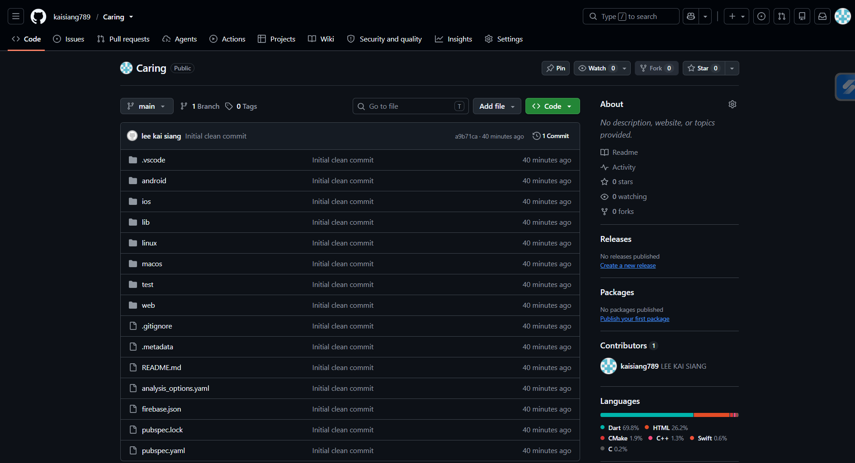
kaisiang789/Caring

Appendix B: Similarity Report

Appendix C: AI Chat/ Prompt History

Appendix D: Paraphrasing Tools

Appendix E: AI tools

Appendix F: Video Presentation

Appendix _: Organisation Chart (if relevant)
Appendix _: Sample of Interview
Appendix _: Sample of Questionnaire
Appendix _: Functions Recording Links
Appendix _: User Manual

